**Short title: Interactions of tomato domestication and Botrytis genetic diversity**

**Crop domestication and pathogen virulence: Interactions of tomato and *Botrytis* genetic diversity**

**Nicole E. Soltis1, Susanna Atwell1, Gongjun Shi1,2, Rachel Fordyce1, Raoni Gwinner1,3, Dihan Gao1, Aysha Shafi1, Daniel J. Kliebenstein\*1,4**

1Department of Plant Sciences, University of California, Davis, One Shields Avenue, Davis, CA, 95616, USA

2Department of Plant Pathology, North Dakota State University, Fargo, ND, 58102, USA

3Department of Agriculture, Universidade Federal de Lavras, Lavras - MG, 37200-000, Brazil

4DynaMo Center of Excellence, University of Copenhagen, Thorvaldsensvej 40, DK-1871, Frederiksberg C, Denmark

**\*Correspondence:** Daniel J. Kliebenstein, Department of Plant Sciences, University of California, Davis, One Shields Ave, Davis, CA, 95616, USA.

**Author Contributions:**

N.S. and D.K. conceived the original research plans; N.S. designed and supervised the experiments; N.S., G.S., R.G., D.G., and A.S. performed most of the experiments; N.S. and R.F. developed the digital image analysis pipeline; N.S., D.G., and A.S. completed digital image analysis; S.A. completed analysis for genomic SNP calls; N.S. performed all statistical analysis of the data; N.S. wrote the manuscript with contributions from all authors; D.K. supervised the writing. D.K. agrees to serve as the author responsible for contact and ensures communication.

**Running title: Crop domestication and Botrytis virulence**

**Key phrases: Botrytis cinerea, plant-pathogen interaction, tomato, domestication, genome wide association mapping**

**Corresponding author:** Daniel J. Kliebenstein, Department of Plant Sciences, University of California, Davis, One Shields Ave, Davis, CA, 95616, USA.

Kliebenstein@ucdavis.edu

Phone: 530-754-7775

**Abstract**

Human selection during crop domestication alters numerous traits, including disease resistance. Little is known about how crop domestication affects quantitative interactions with generalist pathogens. To study how crop domestication impacts plant resistance to generalist pathogens, and correspondingly how this interacts with the pathogen’s genetics, we infected a collection of wild and domesticated tomato accessions with a genetically diverse population of the generalist pathogen *Botrytis cinerea*. We quantified variation in lesion size of 97 *B. cinerea* genotypes (isolates) on 6 domesticated *Solanum lycopersicum* and 6 wild *S. pimpinellifolium* genotypes. Lesion size was significantly controlled by plant domestication, plant genetic variation, and the pathogen’s genotype. Overall, resistance was slightly elevated in the wild tomato accessions. Genome-wide association (GWA) mapping in *B. cinerea* identified a highly polygenic collection of genes. This suggests that breeding against this pathogen would need to utilize a diversity of isolates to capture all possible mechanisms. Critically, we identified a discrete subset of *B. cinerea* genes where the allelic variation was linked to altered virulence against the wild versus domesticated tomato accessions. This indicates that this generalist pathogen already has the necessary allelic variation in place to handle the introgression of wild resistance mechanisms into the domesticated crop.

**Introduction**

Plant disease is mediated by complex interactions among diverse host and pathogen molecular pathways, and the disease outcome is the sum of host plant susceptibility/resistance and pathogen virulence/sensitivity mechanisms. The specific outcome of any interaction is highly dependent on the genetic variation within these pathways in both the host and pathogen. Over time, mutation and selection have led to distinct genetic architectures in the host and pathogen that are at least partly influenced by the host range of the pathogen. Specialist pathogens are a major focus in plant pathology; virulent on a narrow range of hosts, and often limited to a single species or genus. Most known plant genes for resistance to specialist pathogens confer qualitative resistance through innate immunity via large-effect loci that enable the recognition of the pathogen (Dangl and Jones 2001, Jones and Dangl 2006, Dodds and Rathjen 2010, Pieterse, Van der Does et al. 2012). These recognition signals can be conserved pathogen patterns such as cell-wall polymers or flagellin, or alternatively, specific virulence factors that block perception of the pathogen, and in turn are detected by plant proteins that guard the signaling networks (Jones and Dangl 2006, Bittel and Robatzek 2007, Ferrari, Galletti et al. 2007, Boller and He 2009, Dodds and Rathjen 2010). The evolution of large-effect qualitative loci has partly been driven by the narrow host range for the pathogen that enhances co-evolution between host resistance genes and pathogen virulence mechanisms.

In contrast to specialist pathogens, generalist pathogens are virulent across a wide range of plant host species. Generalist pathogens potentially have less stringent co-evolution to specific hosts and their accompanying resistance mechanisms, because these pathogens can easily shift to new hosts in the environment. This allows generalist pathogens to evade the rapid evolution of new resistance mechanisms within specific hosts until they evolve to counter this new resistance. This niche-shifting ability may partially explain the observation that most natural resistance to generalist pathogens is highly polygenic, and the underlying plant genes for resistance are quantitative (Glazebrook 2005, Nomura, Melotto et al. 2005, Goss and Bergelson 2006, Rowe and Kliebenstein 2008, Barrett, Kniskern et al. 2009, Corwin, Copeland et al. 2016). Plant quantitative resistance genes to generalist pathogens include a broad array of direct defense genes, like those involved in secondary metabolite production, cell wall formation, and defense proteins (Zhang, Khan et al. 2002, Denby, Kumar et al. 2004, Zipfel, Robatzek et al. 2004, Ferrari, Galletti et al. 2007, Rowe and Kliebenstein 2008, Poland, Balint-Kurti et al. 2009, Corwin, Copeland et al. 2016). Importantly, these quantitative plant resistance loci do not alter resistance to all genotypes (isolates) of a pathogen but interact with the infecting pathogen’s genotype. For example, the ability of the *Arabidopsis* defense metabolite, camalexin, to provide resistance to *Botrytis cinerea* depends upon whether the specific isolate is sensitive or resistant to camalexin (Kliebenstein, Rowe et al. 2005, Pedras and Ahiahonu 2005, Stefanato, Abou‐Mansour et al. 2009, Pedras, Hossain et al. 2011) and similarly *B. cinerea* virulence on tomato varies with the isolate’s ability to detoxify tomatine (Quidde, Osbourn et al. 1998, Quidde, Büttner et al. 1999). In contrast to the polygenic nature of plant resistance to generalist pathogens, little is known about the genetic architecture of virulence within generalist pathogens, and how this is affected by genetic variation in the plant (Bartoli and Roux 2017). There are no reported naturally variable large-effect virulence loci in generalist pathogens, suggesting that virulence in generalist pathogens is largely quantitative and polygenic. This potential for interaction between polygenic virulence in generalist pathogens and equally polygenic resistance in host plants suggests that we need to work with genetic variation in both the host and pathogen to truly understand quantitative host-pathogen interactions.

A key evolutionary process in plants that has affected resistance to specialist pathogens is the domestication of crop plants. Domesticated plant varieties are typically more sensitive to specialist pathogens than their wild relatives (Smale 1996, Rosenthal and Dirzo 1997, Couch, Fudal et al. 2005, Dwivedi, Upadhyaya et al. 2008), and pathogens may evolve higher virulence on domesticated hosts (Stukenbrock and McDonald 2008). Further, domestication typically imposes a genetic bottleneck that reduces genetic diversity in the crop germplasm, including decreased availability of resistance alleles against specialist pathogens (Tanksley and McCouch 1997, Doebley, Gaut et al. 2006, Chaudhary 2013). These general evolutionary patterns, of lower resistance and allelic diversity found when studying the interaction of specialist pathogens with crop plants, are assumed to similarly hold for generalist pathogens and their domesticated hosts. However, there is less information about how crop host domestication affects disease caused by generalist pathogens, when the resistance to these pathogens is quantitative and polygenic rather than qualitative and monogenic. As such, there is a need to conduct a detailed analysis of how domestication may alter the interaction of a plant with a broad generalist pathogen, and correspondingly, how domestication influences the pathogen.

*Botrytis cinerea* provides a model generalist pathogen for studying quantitative interactions with plant hosts, and underlying evolutionary processes for this generalist in contrast to specialist pathogens. *B. cinerea* is a broad generalist pathogen that can infect most tested plants from bryophytes to eudicots, and causes wide ranging pre- and post-harvest crop losses (Nicot and Baille 1996, Elad, Williamson et al. 2007, Fillinger and Elad 2015). Individual isolates of *B. cinerea* show the same broad host range (Deighton, Muckenschnabel et al. 2001, Finkers, van Heusden et al. 2007, Ten Have, van Berloo et al. 2007, Corwin, Subedy et al. 2016), in contrast to pathogens like *Fusarium oxysporum* where the species can infect diverse hosts, but each isolate is highly host specific (Katan 1999, Ormond, Thomas et al. 2010, Loxdale, Lushai et al. 2011, Barrett and Heil 2012). *B. cinerea* isolates display significant variation in virulence phenotypes, partly due to genetic variation in specific virulence mechanisms, like the production of the phytotoxins, botrydial and botcinic acid (Siewers, Viaud et al. 2005, Dalmais, Schumacher et al. 2011). This genetic variation also influences cell wall degrading enzymes and key regulators of virulence like *VELVET* that quantitatively control virulence on multiple host plants (Rowe and Kliebenstein 2007, Schumacher, Pradier et al. 2012). This genetic variation in diverse virulence mechanisms can contribute to the formation of quantitative differences in virulence between the isolates (ten Have, Mulder et al. 1998). The phenotypic variation is driven by a high level of sequence diversity spread across the genome (Rowe and Kliebenstein 2007, Fekete, Fekete et al. 2012, Atwell, Corwin et al. 2015, Atwell, Soltis et al. 2017). The polymorphism rate in *B. cinerea* was measured as 6.6 SNP/kb, which is more variable than most previously studied plant pathogens (1-2 SNP/kb in *Blumeria graminis*, 1.5 SNP/kb in *Melampsora larici-populina*, 5.5 SNP/kb in the compact genome of the obligate biotroph *Plasmodiophora brassicae*), and close to the genetic diversity found in the human pathogen *Mycobacterium tuberculosis* (2.9 to 6.2 SNP/kb) (Farhat, Shapiro et al. 2013, Hacquard, Kracher et al. 2013, Wicker, Oberhaensli et al. 2013, Persoons, Morin et al. 2014, Desjardins, Cohen et al. 2016, Power, Parkhill et al. 2017). Higher polymorphism rates are reported for the wheat stem rust pathogen *Puccinia graminis* f. sp. *tritici*, from a small non-random sample of isolates (12.3 SNP/kb) (Upadhyaya, Garnica et al. 2014). In addition to SNP diversity, the genomic sequencing showed that *B. cinerea* has a high level of recombination and genomic admixture, as if it were a randomly intermating population. As such, a collection of *B. cinerea* isolates contains genetic variation in a wide range of virulence mechanisms, offering the potential to challenge the host with a blend of diverse virulence mechanisms. This can potentially identify the pathogen variation controlling quantitative virulence, even in non-model plant systems (Bartoli and Roux 2017).

A model pathosystem for studying quantitative host-pathogen interactions during domestication is the tomato-*B. cinerea* system, where the pathogen causes crop loss due to both pre- and post-harvest infection (Dean, Van Kan et al. 2012, Hahn 2014, Romanazzi and Droby 2016). Resistance to *B. cinerea* is a quantitative trait in tomato as with most other species, with identified tomato QTLs each explaining up to 15% of phenotypic variation for lesion size on stems (Dıaz, ten Have et al. 2002, Finkers, van Heusden et al. 2007, Ten Have, van Berloo et al. 2007, Rowe and Kliebenstein 2008, Corwin, Copeland et al. 2016). Tomato is also a key model system to study how domestication influences plant physiology and resistance, including alterations in the circadian clock (Tanksley 2004, Bai and Lindhout 2007, Panthee and Chen 2010, Bergougnoux 2014, Müller, Wijnen et al. 2016), which can modulate resistance to *B. cinerea* (Sauerbrunn and Schlaich 2004, Weyman, Pan et al. 2006, Bhardwaj, Meier et al. 2011, Hevia, Canessa et al. 2015). This suggests that host plant domestication within tomato can alter traits known to influence *B. cinerea* resistance from other systems. Tomato domestication is typically considered a single event, followed by extensive crop improvement (Lin, Zhu et al. 2014, Blanca, Montero-Pau et al. 2015). Thus, we are using the tomato-*B. cinerea* pathosystem to directly measure the interaction of crop domestication with genetic variation in a generalist pathogen to better understand the evolution of this pathosystem.

In this study, we infected 97 genetically diverse *B. cinerea* isolates on a collection of domesticated tomato, *S. lycopersicum*, and wild tomato, *S. pimpinellifolium*, and quantified the interaction through lesion size in a detached leaf assay. Previous studies have examined *B. cinerea* resistance between domesticated and distantly related wild tomato species (i.e. *S. lycopersicum* and *S. pimpinellifolium*) using single isolates of pathogens (Egashira, Kuwashima et al. 2000, Nicot, Moretti et al. 2002, Guimaraes, Chetelat et al. 2004, Ten Have, van Berloo et al. 2007, Finkers, Bai et al. 2008). These previous studies typically used individual wild and domesticated tomato accessions that were the founders of mapping populations, and found a wide range of *B. cinerea* resistance. However, it is still unknown how domesticated and closely related wild tomatoes compare for *B. cinerea* resistance using multiple plant genotypes and a population of the pathogen. We selected accessions to sample major geographic origins of the progenitor species, and focused the domesticated germplasm on diverse mid- to late- 20th century improved germplasm (Lin, Zhu et al. 2014, Blanca, Montero-Pau et al. 2015). In this study, we asked whether *B. cinerea* virulence was controlled by host variation, pathogen variation, or the interaction between them. Lesion size of *B. cinerea* is a quantitative trait that was controlled by plant domestication status, plant genotype and pathogen isolate. We looked for evidence of specialization within our generalist pathogen population. While our *B. cinerea* isolates appear to be generalists across domestication in *Solanum,* a subset of isolates is sensitive to tomato domestication. Finally, we aimed to identify the genetic basis of variation in *B. cinerea* virulence on domesticated and wild tomato. We conducted genome-wide association (GWA) in *B. cinerea* to identify pathogen loci where genetic variation leads to altered virulence across the host genotypes, including a specific test for loci that influence responses to crop domestication. Few studies have conducted GWA in plant pathogens for virulence phenotypes, and most of these were limited by few variable loci or few genetically distinct isolates (Dalman, Himmelstrand et al. 2013, Gao, Liu et al. 2016, Talas, Kalih et al. 2016, Wu, Sakthikumar et al. 2017). To ensure that genetic inference was independent of the GWA method or SNP diversity reference, we repeated genetic analysis with two different association methods (bigRR and GEMMA) using SNPs called in comparison to two published *B. cinerea* genomes (T4 and B05.10). All methods converged on the same image of genetic architecture; virulence of *B. cinerea* is highly quantitative, with hundreds of significant SNPs with small effect sizes associated with lesion area on each tomato genotype. Importantly, there is a subset of loci in the pathogen where allelic variation gives the isolates opposing responses to crop domestication. These pathogen loci could provide tools for understanding how domestication in tomato has influenced generalist pathogen resistance, to inform breeding efforts.

**Results**

**Experimental Design**

To measure how tomato domestication affects quantitative resistance to a population of a generalist pathogen, we infected a collection of 97 diverse *B. cinerea* isolates (genotypes) on wild and domesticated tomato genotypes. We compared domesticated and closely related wild tomatoes for *B. cinerea* resistance using multiple plant genotypes and a population of the pathogen. We selected 6 domesticated *Solanum lycopersicum* and 6 wild *S. pimpinellifolium* accessions, the closest wild relative of *S. lycopersicum*, to directly study how domestication has influenced resistance to *B. cinerea* (Peralta, Spooner et al. 2008, Müller, Wijnen et al. 2016)(Figure S1). Our previously collected *B. cinerea* sample includes 97 isolates obtained from various eudicot plant hosts, including tomato stem tissue (2 isolates; T3, KT) and tomato fruit (3 isolates; KGB1, KGB2, Supersteak)(Atwell, Soltis et al. 2017). We infected all 97 *B. cinerea* isolates onto each of the 12 plant genotypes in 3-fold replication across 2 independent experiments in a randomized complete block design, giving 6 measurements per plant-pathogen combination, for a total of 3,276 lesions. Digital measurement of the area of the developing lesion provides a composite phenotype controlled by the interaction of host and pathogen genetics. This measurement of the plant-*B. cinerea* interaction has been used successfully in a number of molecular and quantitative genetic studies (Ferrari, Plotnikova et al. 2003, Denby, Kumar et al. 2004, Kliebenstein, Rowe et al. 2005, Ferrari, Galletti et al. 2007, Ten Have, van Berloo et al. 2007, AbuQamar, Chai et al. 2008, Rowe and Kliebenstein 2008, Liu, Hong et al. 2014). It should be noted that we are not focusing on MAMP or PAMP specific host/pathogen interactions with this study, we are instead allowing the identification of any mechanism that may influence the host/pathogen interaction including metabolism, development or any other unknown component. As long as there is genetic variation affecting the trait, and the trait influences the interaction of host and pathogen, it will be a component of the experiment. This fits with the recently developing view that growth, development and resistance in plants are highly integrated processes that may not be as distinct as once believed (Campos, Yoshida et al. 2016, Ballaré and Pierik 2017, Züst and Agrawal 2017, Izquierdo‐Bueno, González‐Rodríguez et al. 2018).

**Lesion size (phenotypic) variation**

We collected images of all lesions at 24, 48, and 72 hours post inoculation. At 24 hours, no visible lesions were present on the tomato leaves. At 48 hours, a thin ring of primary lesion became visible surrounding the location of the spore droplet, but no expansion was visible. At 72 hours significant lesion growth was visible, but no lesions had spread to infect over half of the leaflet. We digitally measured the area of all developing lesions at 72 hours post infection (HPI) as a measure of virulence (Figure 1). We observed a mean lesion size of 0.67 cm2 across the full experiment, with 0.94 CV across the full isolate population on all tomato genotypes. Individual isolates were highly variable in their lesion size across tomato genotypes (Figure 1 c-h), with mean lesion size per isolate of 0.14 cm2 to 1.29 cm2, and individual isolate coefficient of variation (CV) from 0.51 to 1.68 across all observations on all tomato genotypes (Table S1). A subset of these isolates are highly virulent on tomato (mean lesion size > 1.05 cm2, Figure 1e), and a subset can be considered saprophytic (mean lesion size < 0.3 cm2, Figure 1f).

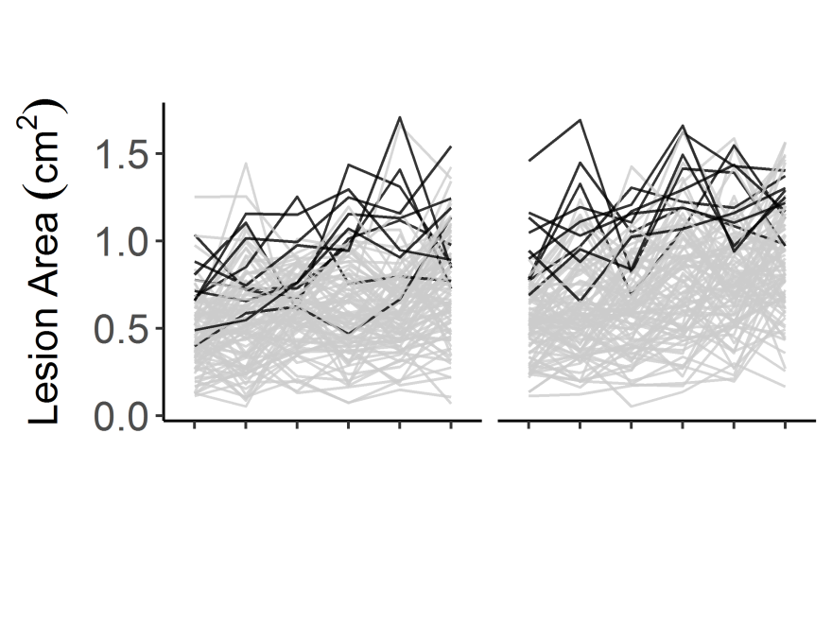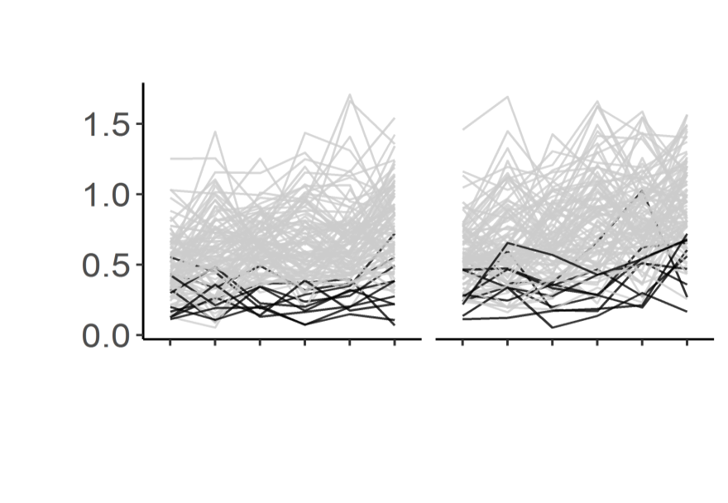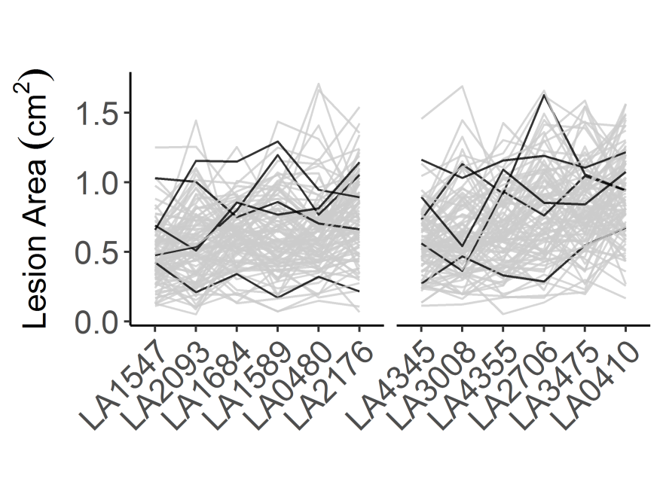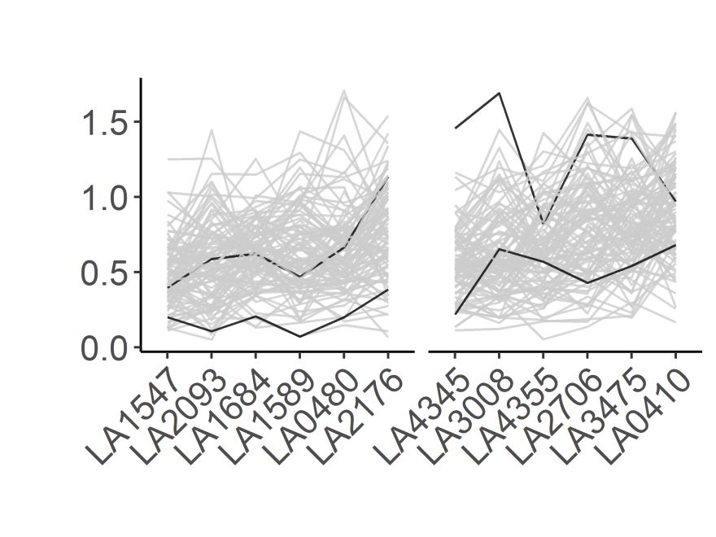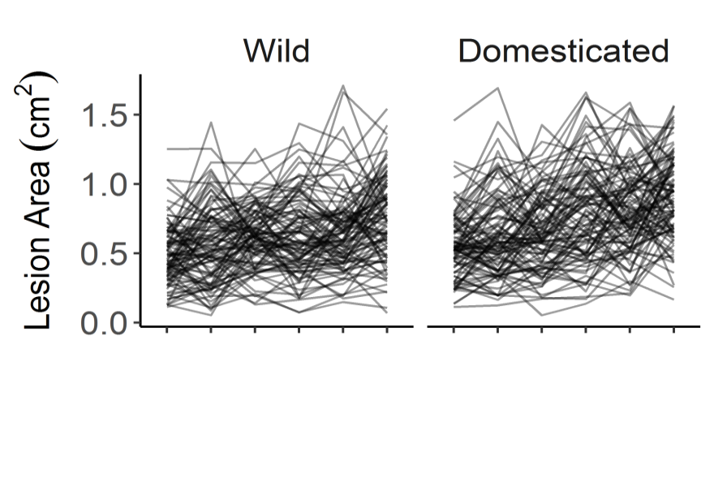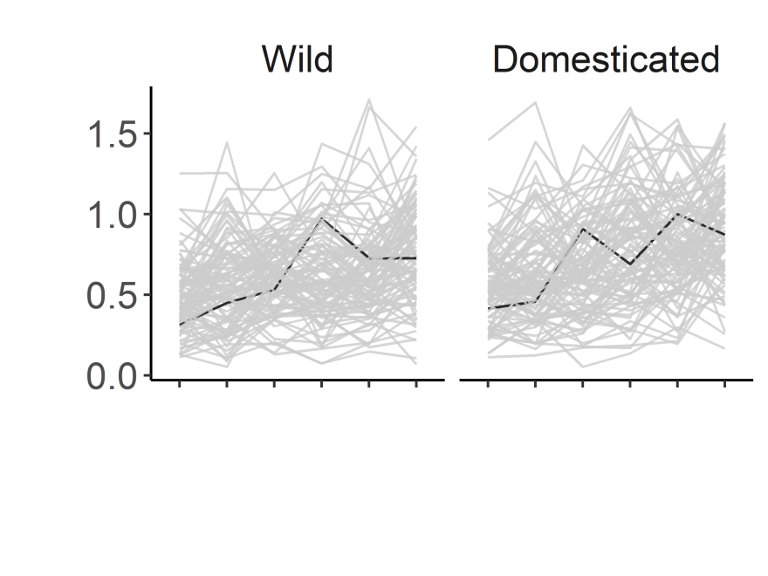

**c**

**d**

**e**

**f**

**g**

**h**

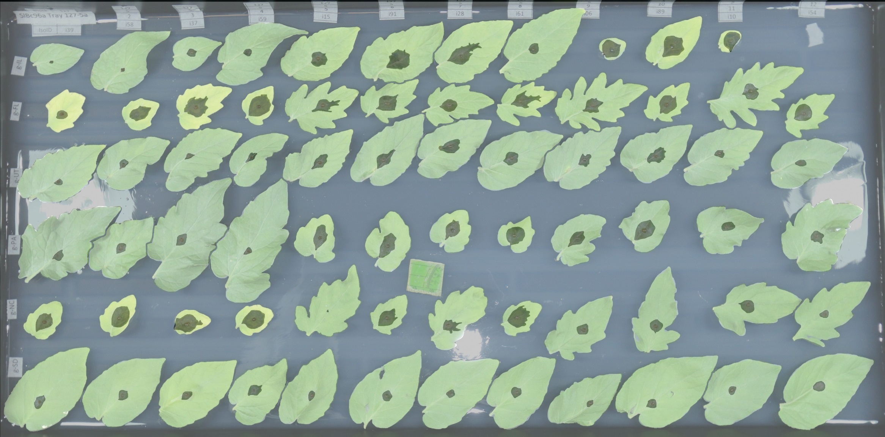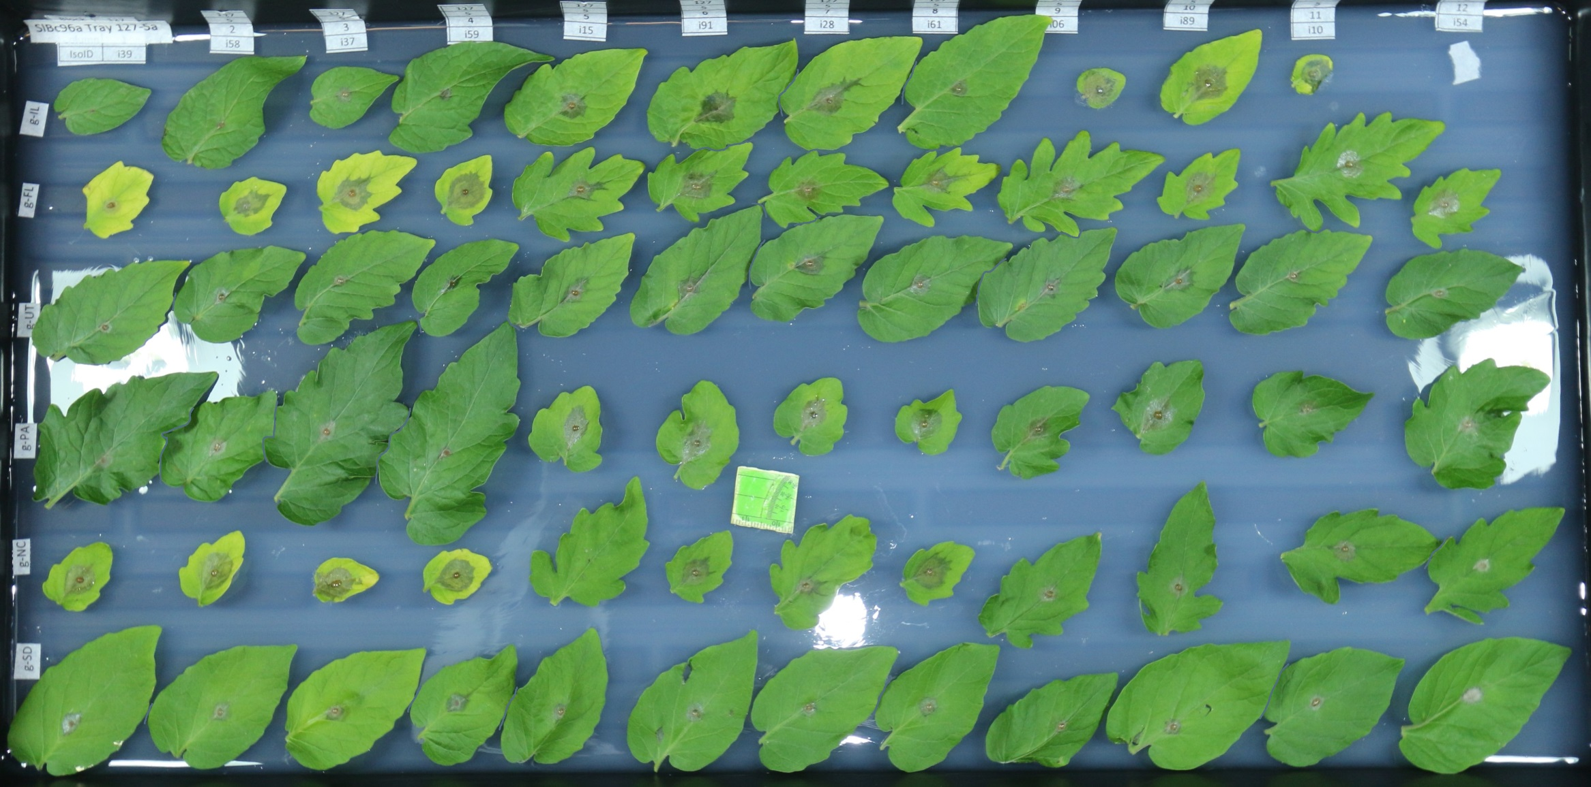

**a**

**b**

**Figure 1. *Botrytis cinerea* x tomato diversity in detached leaf assay and digital image analysis.** a) Individual tomato leaflets of 6 *S. lycopersicum* genotypes and 6 *S. pimpinellifolium* genotypes are in randomized rows, spore droplets of individual *B. cinerea* isolates are in randomized columns. Digital images are collected 72 hours post inoculation. Single droplets of 40 *B. cinerea* spores are infected on randomized leaflets using randomized isolates, and digital images are taken 72 hours post inoculation.

b) Digital masking of leaf and lesion is followed by automated measurement of area for each lesion.

c-h) Variation in lesion size resulting of the interaction of *B. cinerea* and diverse tomato genotypes.

c) Average lesion size of single *B. cinerea* isolates (line traces) across tomato host genotypes grouped by domestication status.

d) Highlight of the common reference *B. cinerea* isolate B05.10.

e) Highlight of the ten highest-virulence isolates, as estimated by mean virulence across all tomato genotypes.

f) Highlight of the ten most saprophytic, or low virulence, isolates, as estimated by mean virulence across all genotypes.

g) Highlight of the five isolates collected from tomato tissue.

h) Highlight of the two isolates with significant domestication sensitivity.

**Contribution of Pathogen Genetics, Plant Genetics and Crop Domestication Effects on Resistance**

To measure the relative contribution of genetic diversity in the plant and the pathogen to variation in the virulence/ susceptibility phenotype, we used a multiple linear regression model (R Development Core Team 2008). This model directly tested the contribution of plant genotype, plant domestication status, and pathogen genotype (isolate) to variation in lesion size. The final model showed that genetic variation within both the host plant and the pathogen had significant effects on lesion growth, with pathogen isolate diversity explaining 3.5 fold more variance than plant genotype, 46% of total genetic variance for pathogen isolate vs. 13% for plant genotype (Table 1 and Figure 1c). Interestingly, tomato domestication status significantly impacted *B. cinerea* virulence, as shown by the small but significant effects of genetic variation between domesticated and wild tomatoes (3.5% of total genetic variance, Table 1). There was no evidence for significant interaction effects between pathogen isolate and plant genotype, but this term contributed the largest proportion of the plant-related variance in lesion size (34% of total genetic variance, Table 1). The lack of significance for this term in face of the large fraction of variance may be due to the vast degrees of freedom in this term (Table 1). Thus, the interaction between tomato and *B. cinerea* was significantly controlled by genetic diversity within the host plant and the pathogen, including a slight effect of domestication status.

**Table 1. ANOVA results of the interaction between 12 tomato accessions and 95 *B. cinerea* isolates measured as lesion area.**

The Type III Sums-of-Squares, F-value, Degrees of Freedom and p-value for the linear modelling of lesion area for 12 tomato accessions by 95 *B. cinerea* isolates is shown. Two of our 97 isolates did not have replication across 2 experiments, so they were dropped at this stage of analysis. The terms are as follows; Isolate is the 95 *B. cinerea* isolates, Domestication is wild tomato, *S. pimpinellifolium*, versus domestic tomato, *S. lycopersicum*, Plant is 12 tomato genotypes nested within their respective domestication groupings, Experiment tests the 2 independent replicate experiments, Experiment/Block tests the three blocks nested within each experiment. In addition, interactions of these factors are tested (:).

|  |  |  |  |  |  |  |
| --- | --- | --- | --- | --- | --- | --- |
| Fixed Effect | % total variance | % genetic variance | SS | F value | DF | p |
| Isolate | 10.2 | 45.8 | 256.6 | 13.5 | 94 | **<2e-16** |
| Domestication | 0.8 | 3.5 | 19.5 | 96.5 | 1 | **<2e-16** |
| Domest/Plant | 2.9 | 13.2 | 73.7 | 36.5 | 10 | **<2e-16** |
| Iso:Domest | 0.8 | 3.7 | 20.7 | 11 | 94 | 0.260 |
| Iso:Domest/Plant | 7.5 | 33.8 | 189.5 | 1.0 | 940 | 0.623 |
| Experiment | 21.7 |  | 545.7 | 2707 | 1 | **<2e-16** |
| Exp/Block | 8.0 |  | 201.0 | 249.3 | 4 | **<2e-16** |
| Exp:Iso | 6.0 |  | 152.2 | 8.0 | 94 | **<2e-16** |
| Exp:Domest | 0.03 |  | 0.8 | 4.1 | 1 | 0.043 |
| Exp:Domest/Plant | 1.9 |  | 47.4 | 23.5 | 10 | **<2e-16** |
| Residuals | 40.1 |  | 1009 |  |  |  |

**Domestication and Lesion Size Variation**

Existing literature predominantly reports that crop domestication decreases plant resistance to pathogens (Smale 1996, Rosenthal and Dirzo 1997, Couch, Fudal et al. 2005, Dwivedi, Upadhyaya et al. 2008, Stukenbrock and McDonald 2008). In our analysis, we identified a significantly greater (18%) resistance of wild tomato in comparison to domesticated tomato across the population of *B. cinerea* isolates (Figure 2 and 3, Table 1). However, this domestication effect was not the dominant source of variation, as genetic variation within the domesticated and wild genotypes contributed 3.8 fold more variation in resistance than domestication alone (Table 1). While we did observe the expected decreased resistance in domesticated tomato, domestication was a minor player in controlling lesion size variation, with most of the plant genetic signature coming from variation within both the wild and domesticated tomato species.

In addition to altering trait means, domestication commonly decreases genetic variation in comparison to wild germplasm due to bottlenecks, including for tomato (Tanksley and McCouch 1997, Doebley, Gaut et al. 2006, Bai and Lindhout 2007). We would expect this decreased genetic variation to limit phenotypic variation, including disease phenotypes. Interestingly in this tomato population, we did not observe reduced variation in lesion size in the wild tomato. Rather, the domesticated tomato genotypes had a wider range of average lesion size than wild genotypes; the 90th percentile range (95th percentile to 5th percentile) spanned 2.03 cm2 lesion size variation on domesticated tomato (standard deviation = 0.68 cm2) versus 1.76 cm2 variation on wild tomato (standard deviation = 0.58 cm2). Additionally, the wild and domesticated tomato genotypes showed statistically similar variation in resistance (F-test, F96,96=1.39, p=0.11) (Figure 3, Figure S1). Overall, there is a slight domestication impact on average resistance to *B. cinerea*, but no evidence of a phenotypic bottleneck due to domestication.

C:\Users\nesoltis\Documents\Projects\BcSolGWAS\paper\plots\FigR2\FigR2_beanplot_nogrid.tiff

**Figure 2. Distribution of tomato genotype susceptibility toinfection with 97 genetically diverse *B. cinerea* isolates.**

Violin plots show the distribution of lesion size caused by *B. cinerea* isolates on each tomato host genotype. Individual points are mean lesion size for each of the 97 different isolate-host pairs. The boxes show the 75th percentile distribution, and the horizontal line shows the mean resistance of the specific host genotype. The tomato genotypes are grouped based on their status as wild or domesticated germplasm.

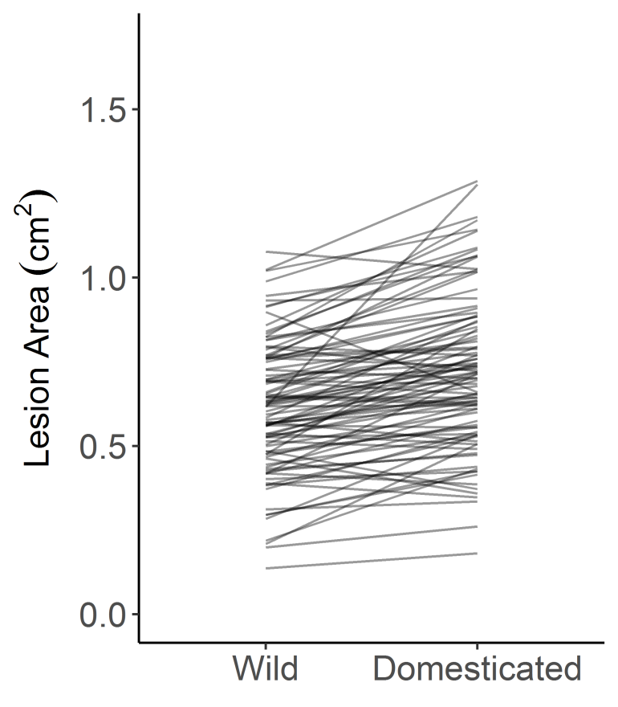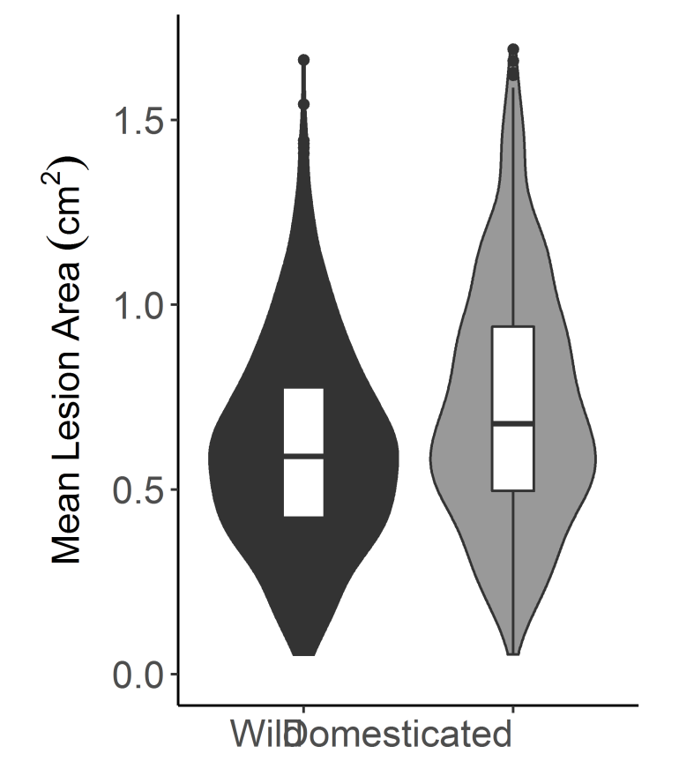

**Figure 3. Distribution of *B. cinerea* virulence by tomato domestication status**.

The violin plots show the mean virulence of each *B. cinerea* isolate on the tomato genotypes, grouped as wild or domesticated germplasm. The domestication effect on lesion size is significant (Table 1 ANOVA, p<2e-16). The interaction plot between the two violin plots connects the average lesion size of a single *B. cinerea* isolate between the wild and domesticated germplasm.

**Pathogen Specialization to Source Host**

One evolutionary model of plant-generalist pathogen interactions suggests that generalist pathogen isolates within a species may specialize for interaction with specific hosts. Alternatively, generalist isolates may show no host specialization or preference. Our collection of *B. cinerea* includes five isolates that may be adapted to tomato, as they were collected from *S. lycopersicum*. To test if there is evidence for specialization to the source host, we compared the virulence of the *B. cinerea* isolates obtained from tomato to the broader pathogen population. For *B. cinerea* genotypes isolated from tomato tissue vs. other hosts, there was no significant difference in lesion size on domesticated tomato (t-test; t=1.10, n = 97, p=0.33), wild tomato (t-test; t=1.09, n = 97, p=0.33) or across all tomato genotypes (t-test; n = 97, p=0.14) (Figure 1g). In fact, one isolate collected from tomato tissue (KGB1) was within the 10 least-virulent isolates and another (Triple3) was within the 10 most-virulent isolates (Figure 1g). This demonstrated significant genetic variation in virulence across the *B. cinerea* isolates, and that this collection of *B. cinerea* isolates from tomato do not display a strong host-specificity for tomato (Martinez, Blancard et al. 2003, Ma and Michailides 2005, Rowe and Kliebenstein 2007, Samuel, Veloukas et al. 2012).

**Pathogen Specialization to Host Genotype**

Though we did not find evidence for *B. cinerea* adaptation to tomato based on isolate host source, the *B. cinerea* isolates may contain genetic variation at individual loci that allow them to better attack subsets of the tomato genotypes (Rowe and Kliebenstein 2007, Kretschmer and Hahn 2008, Corwin, Subedy et al. 2016). A visual analysis of the data suggested an interaction between the genomes of *B. cinerea* and tomato (Figure 1 c-h). However, when using the full model, we found no significant interaction between isolate and individual host genotype, even though there was a large fraction of variance within these terms (Table 1). This may indicate a lack of interaction between genetic variation in the host and pathogen. However, this negative result may also be due to low power in F-tests in factors with high degrees of freedom, as in the case of the isolate by plant genotype interaction term with 940 degrees of freedom (Table 1). To assess these possibilities, we used an additional statistical approach to test for an interaction between *B. cinerea* and host genotype. We used a Wilcoxon signed-rank test to test if the rank of *B. cinerea* isolate-induced lesion size significantly changes between pairs of tomato genotypes. This showed that when using the full isolate population, the rank performance of the isolates does significantly vary between host genotypes. When comparing mean lesion size between paired plant genotypes, 58% (38 out of 66) of tomato accession pairs had significantly different ranking of the isolates (Wilcoxon signed-rank test with Benjamini-Hochberg FDR-correction, Table 2, Figure S2,). A significant p-value indicates that the two host genotypes show evidence for different virulence interactions with the population of *B*. *cinerea* isolates, providing evidence for host x pathogen genotypic interactions. This pattern was consistent across domesticated host pairs, wild host pairs, or between-species host pairs (Wilcoxon signed-rank test with B-H FDR-correction, Table 2). This suggests that the population of *B. cinerea* does display differential responses to the tomato genetic variation.

To focus on whether specific *B. cinerea* isolates may be sensitive to domestication, we applied a Wilcoxon and ANOVA approach. Overall, most isolates (78/97, 80%) are more virulent on domesticated than wild tomato (Figure 3). The Wilcoxon signed-rank test, to compare the rank of mean lesion size of all the *B. cinerea* isolates on wild versus domesticated tomato, was significant (Wilcoxon signed-rank test, W = 5946, p-value = 0.002) (Figure 3). To identify the pathogen genotypes most sensitive to domestication, we conducted single-isolate ANOVAs including the fixed effects of plant, domestication, and experiment, and found two isolates with a significant effect of domestication on lesion size (p < 0.05, FDR corrected) (Figure 1h), both of which are more virulent on domesticated tomato. These included one of the highly virulent isolates (Fd2), and one of the largely saprophytic isolates (Rose), which suggests that isolate virulence level on tomato does not predict *B. cinerea* genetic response to tomato domestication. Both of these isolates were more virulent on domesticated than on wild tomato. These results suggest that this *B. cinerea* population contains two highly domestication-sensitive isolates which are more virulent on domesticated tomato, and a broader pattern of *B. cinerea* sensitivity to tomato genetic variation.

**Table 2. Rank order shifts of 97 *B. cinerea* isolates by lesion area across all of the tomato accessions.**

Wilcoxon signed-rank test comparing mean *B. cinerea* lesion area on tomato accessions. This tests for a change in the rank order of the 97 isolates between each pair of tomato accessions. A significant p-value suggests that the relative performance of individual isolates is altered from one host to the other. The lower left corner of the chart includes B-H FDR-corrected p-values, the upper right corner includes the test statistic (W). Bold text indicates significance at p < 0.01 after correction, italicized text indicates suggestive p-values 0.01 < p < 0.1. NS shows non-significant interactions.

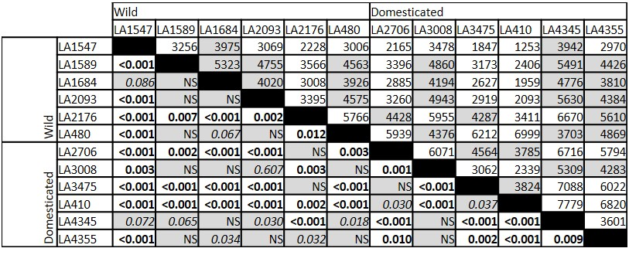

**Quantitative Genetics of Pathogen Virulence on Tomato**

Genetic variation within *B. cinerea* had a large effect on virulence on tomato and interacted with tomato domestication (Table 1). This suggests that there is genetic variation within the pathogen in which some alleles enhance and other alleles decrease virulence depending upon the plant’s genotype. To identify variable pathogen genes controlling differential virulence across plant genotypes, we conducted GWA mapping analysis within the pathogen by two approaches. Due to the large effect of plant genotype on resistance to *B. cinerea*, we performed GWA using the model-corrected least-squared mean virulence measured on each tomato genotype as separate traits. We first used a ridge-regression approach in combination with 272,672 SNPs from *B. cinerea* compared to the T4 reference genome to estimate the phenotypic effects across the genome (Shen, Alam et al. 2013, Corwin, Copeland et al. 2016, Corwin, Subedy et al. 2016, Francisco, Joseph et al. 2016). To verify these patterns, we also implemented a Genome-wide Efficient Mixed-Model Association (GEMMA) analysis with a centered relatedness matrix to control for the effects of population structure (Zhou and Stephens 2012). In GEMMA, we included 237,878 SNPs from *B. cinerea* compared to the B05.10 reference genome. To determine significance of SNP effects under both GWA methods, we permuted phenotypes 1000 times to calculate 95, 99, and 99.9% effect size thresholds within each plant host. This GWA analysis showed that the genetic basis of *B. cinerea* virulence on tomato is highly polygenic. The ridge-regression approach (bigRR) identified from 1,284 to 25,421 SNPs within *B. cinerea* that were significantly associated with altered virulence on the 12 different host genotypes (significance was determined by the SNP effect size estimate exceeding the 99% 1000-permutation threshold). There were no SNPs with large effect sizes, showing the polygenic nature of the trait in the pathogen (Figure 4). The model accounting for population structure (GEMMA) confirmed our finding of a highly polygenic nature of lesion size in the pathogen (Figure S3), with 2,530 to 8,221 SNPs significantly associated with virulence at the 99% threshold, and 288 to 1,361 SNPs at the 99.9% threshold (significance was determined using an empirically determined 1000-permutation threshold).

While only a small subset of these *B. cinerea* SNPs were linked to virulence on all the tomato genotypes, we were able to obtain better overlap by focusing on gene windows. We found five *B. cinerea* SNPs significantly linked to altered lesion size on all 12 tomato accessions using the bigRR analysis (Figure 4b). 215 SNPs were called in at least ten hosts, and 3.3k SNPs were called in at least half of the hosts while 27% (46,000) of the significant SNPs were linked to virulence on only a single host tomato genotype. These levels of overlap exceed the expected overlap due to random chance (Figure 5a). GEMMA analysis also found significant SNP overlap between hosts at the 99% permutation threshold, with 89 SNPs in at least ten hosts, 859 SNPs in at least half of the hosts, and 63% (19,270) of significant SNPs unique to a single host. SNP calling between hosts was lower for GEMMA at the 99.9% permutation threshold, with 78% of significant SNPs (4269) in a single host, and 38 SNPs significant across at least half of the hosts (Figure S4a). To change from a SNP-by-SNP focus to a gene-centric focus, we classified a gene as significantly associated if there was 1 SNP linked to a trait using a 2kbp window surrounding the start and stop codon for a given gene. This analysis identified 14 genes linked to differential virulence in all 12 tomato accessions by bigRR (Figure 5b, Table S2e), as some SNPs within a gene had accession-specific phenotypes (significant in <12 tomato accessions). A further 1045 genes were linked to differential virulence on 7 to 11 of the tomato accessions by bigRR (Figure 5b, Table S2e). At the 99.9% SNP significance threshold, GEMMA identified 23 genes across 7 to 9 of the tomato accessions (Figure S4).

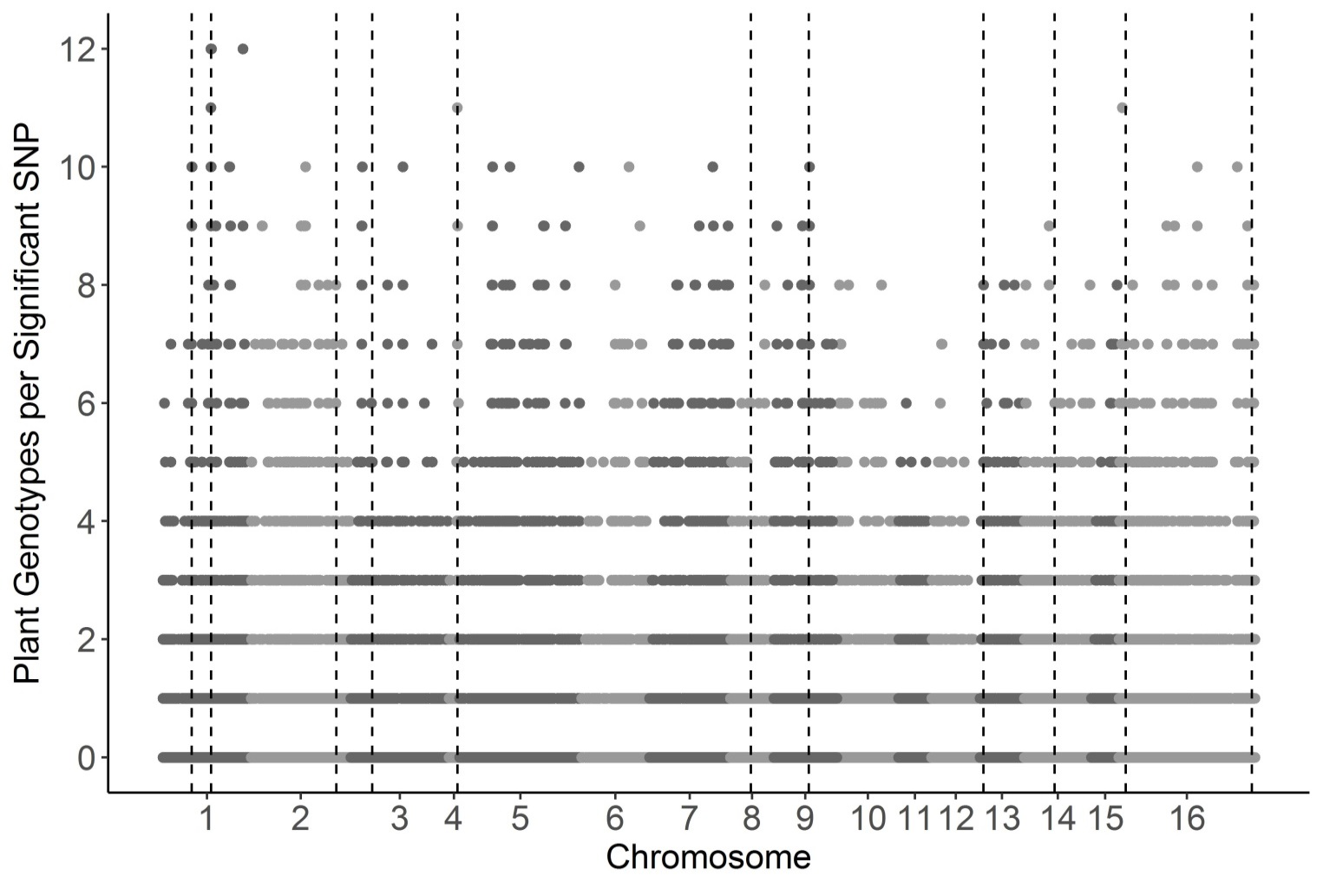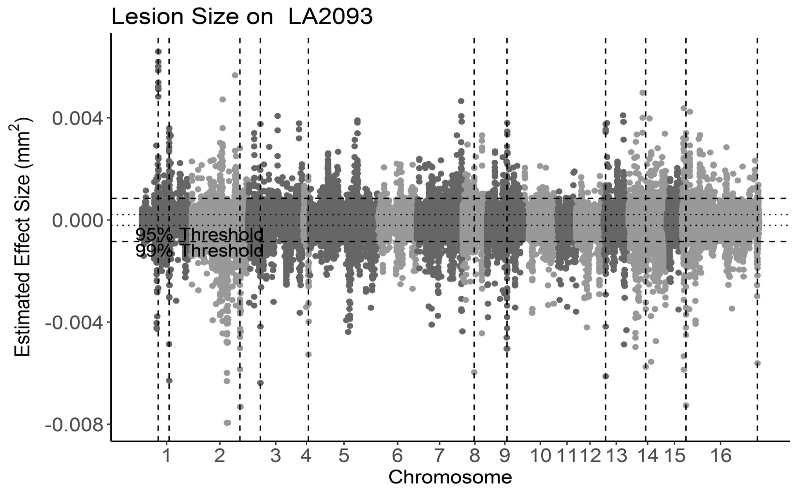

**a**

**b**

**Figure 4. GWA of *B. cinerea* lesion size on individual tomato genotypes.**

*Botrytis cinerea* chromosomes are differentiated by shading, alternating light and dark grey.

a) Manhattan plot of estimated SNP effect sizes from bigRR for *B. cinerea* lesion size using a single tomato accession, LA2093. Permutation-derived thresholds are shown in horizontal dashed lines.

b) The number of tomato accessions for which a *B. cinerea* SNP was significantly linked to lesion development by bigRR using the 99% permutation threshold. Frequency is number of phenotypes in which the SNP exceeds the threshold. Vertical dotted lines identify regions with overlap between the top 100 large-effect SNPs for LA2093 and significance across the majority (≥6) of tomato genotypes tested.

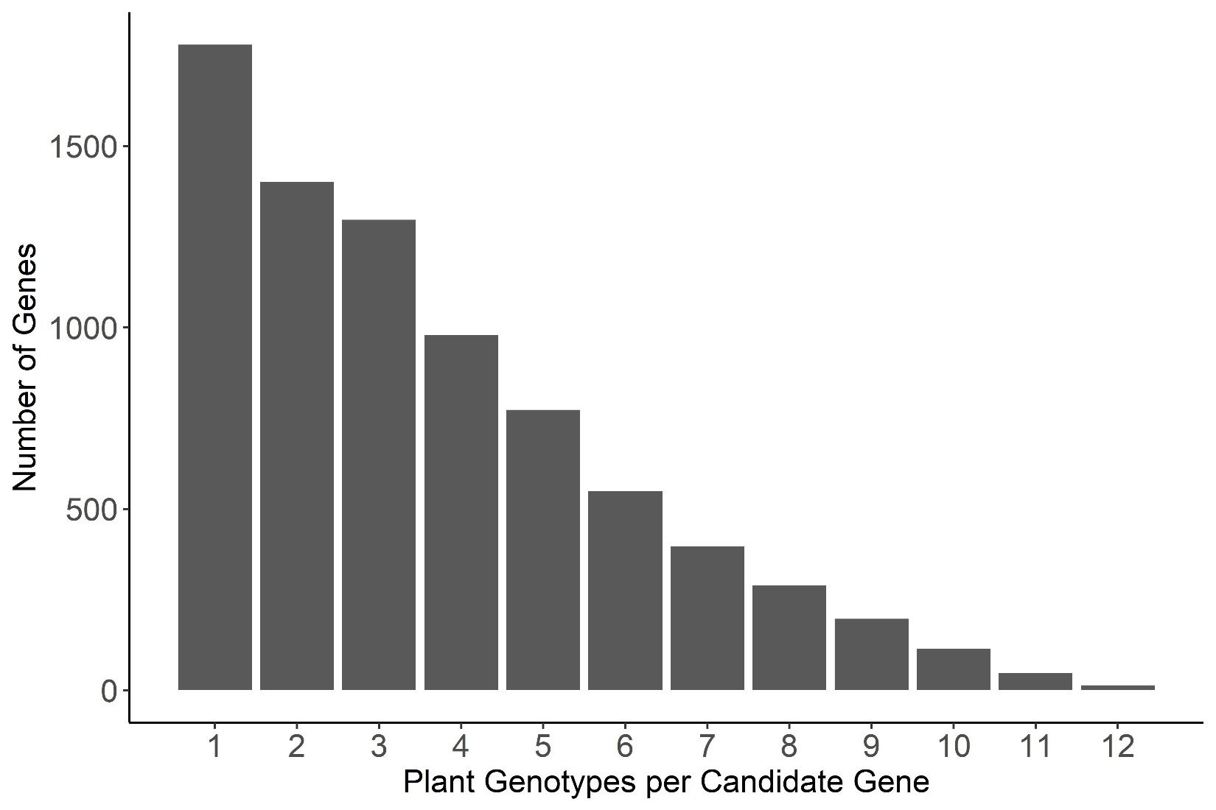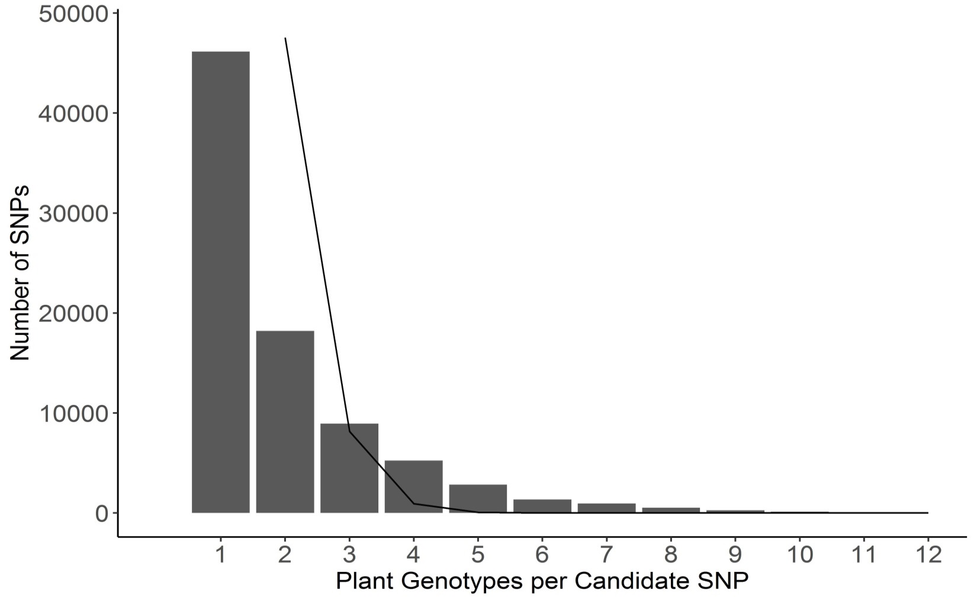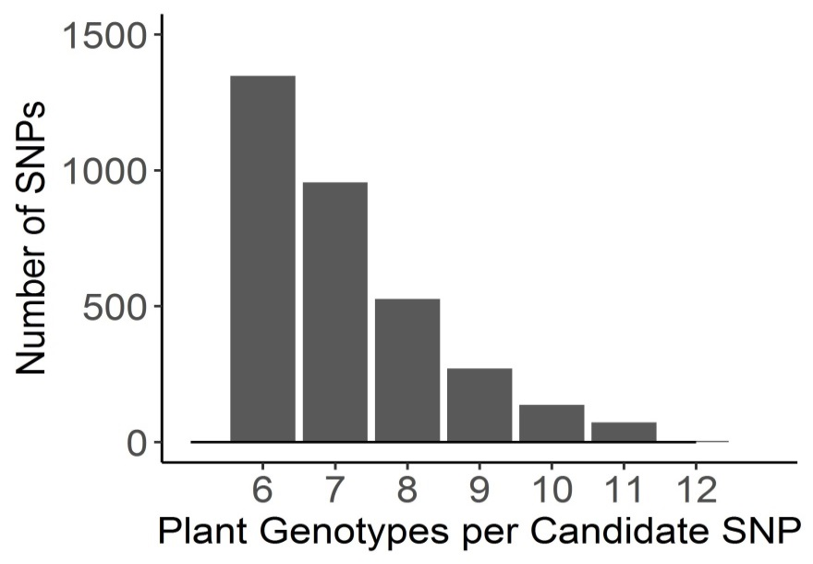

**a**

**b**

**Figure 5. Frequency of overlap in *B. cinerea* GWA significance across tomato accessions.**

a) The frequency with which the *B. cinerea* SNPs significantly associate with lesion size on the 12 tomato accessions using bigRR and the 99% permutation threshold. The black line indicates the expected frequency of random overlap, given the number of significant SNPs per plant genotype and size of total SNP set. The inset zooms in on the distribution for overlapping SNPs above 6 plant genotypes for easier visualization. There were no SNPs expected to overlap by random chance in the inset.

b) The frequency with which *B. cinerea* genes significantly associated with lesion size on the 12 tomato accessions. Genes were called as significant if there was one significant SNP called at the 99% permutation threshold within the gene body, or within 2kb of the gene body.

Of the 14 genes with SNPs significantly associated with *B. cinerea* virulence on all

tomato genotypes by bigRR, most have not been formally linked to pathogen virulence. However, SNPs within a pectinesterase gene (BcT4\_6001, Bcin14g00870) were associated to virulence across 11 tomato accessions. Pectinesterases are key enzymes for attacking the host cell wall, suggesting that variation in this pectinesterase locus and the other loci may influence pathogen virulence across all the tomato genotypes (Valette-Collet, Cimerman et al. 2003). Therefore, we looked for evidence of multiple haplotypes in this locus linked to virulence by visualizing the SNP effects across the pectinesterase gene. We plotted the effect sizes for all SNPs in this gene and investigated the linkage disequilibrium amongst these SNPs (Figure 6). This showed that the effect of SNPs across this gene vary in effect direction depending on tomato host genotype (Figure 6a). We identified two haplotype blocks contributing to the association of this gene to the virulence phenotype (Figure 6b). One block is associated with SNPs in the 5’ untranslated region in SNPs 5-11, and the second block is SNPs that span the entirety of the gene in SNPs 13-26. Interestingly, there are only two SNPs in the open reading frame of the associated gene (Figure 6). This suggests that the major variation surrounding this locus is controlling the regulatory motifs for this pectinesterase. Thus, there is significant genetic variation in *B. cinerea* virulence that is dependent upon the host’s genetic background. This suggests that the pathogen relies on polygenic small effect loci, potentially allowing selection to customize virulence on the different tomato hosts.

To identify genes consistently associated with *B. cinerea* virulence on tomato across GWA methods, we examined the gene overlap between significant associations identified by GEMMA on the B05.10 genome and bigRR on the T4 genome. We conservatively identified genes within 2kb of significant SNPs at the 99% permutation threshold for bigRR, and at the 99.9% permutation threshold for GEMMA. Among these, 263 genes were linked to at least two plant genotypes by both methods (Table S2a). These genes include transporters and enzymes that can be important for Botrytis toxin production and/or detoxification of plant defense compounds and are key to virulence. Other known and predicted pathogen virulence functions were largely not identified (Table S2a, c).

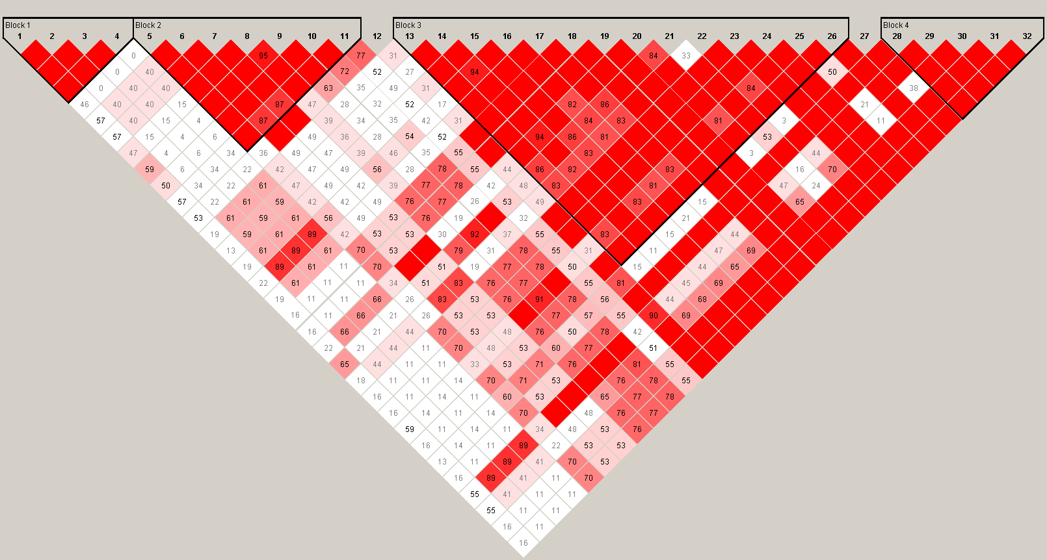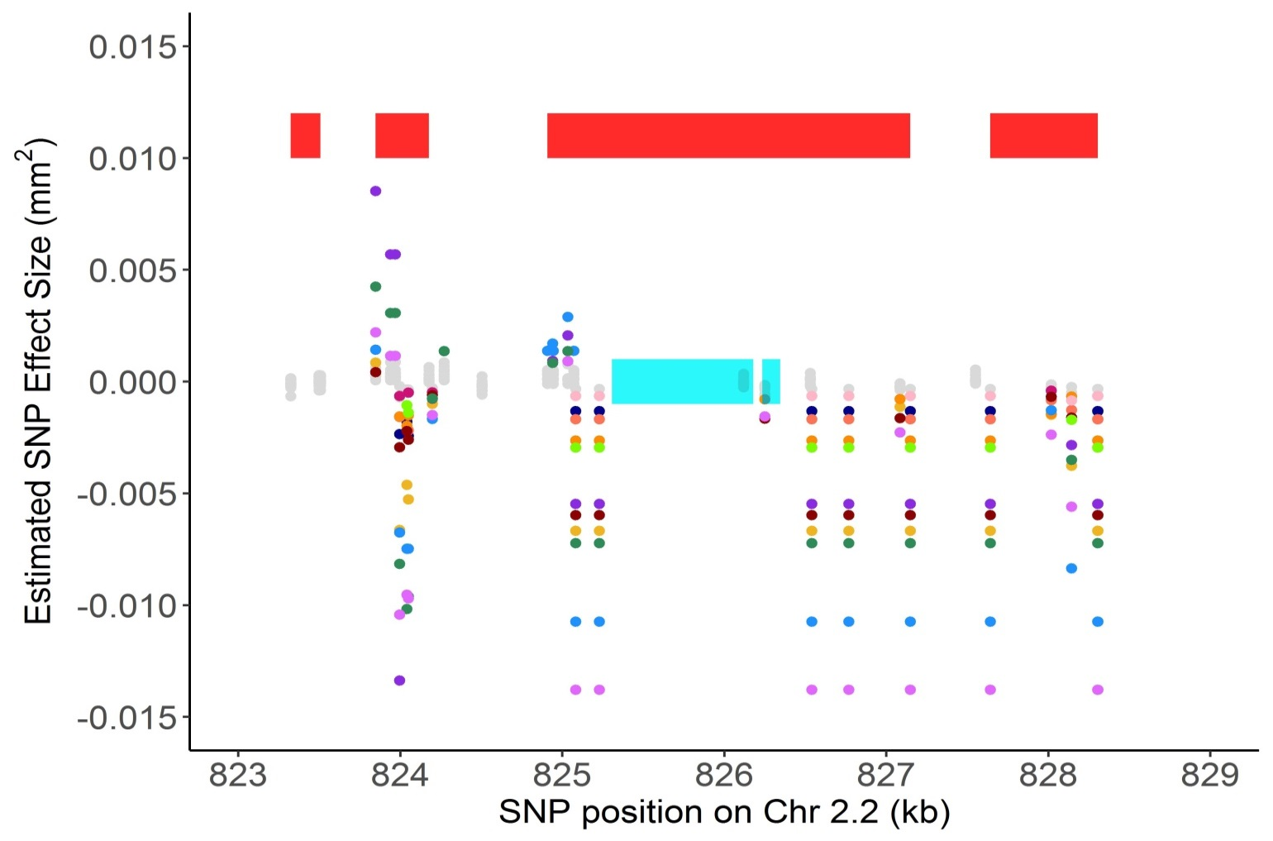

Block 1

Block 2

Block 3

Block 4

**a**

**b**

**Figure 6. Host specificity of significant SNPs linked to the gene BcT4\_6001 (Bcin14g00870).**

a) SNPs with effects estimates above the 99% permutation threshold are colored by trait (plant phenotype in which the effect was estimated). BcT4\_6001 (Bcin14g00870) is a pectinesterase gene linked to at least one significant SNP on all 12 of the tested tomato accessions by bigRR. The annotated exons are depicted as turquoise rectangles, with the start codon marked with an arrow indicating the direction of transcription. Red rectangles indicate corresponding linkage disequilibrium blocks from Figure 6b.

b) Linkage disequilibrium plot, including all pairwise comparisons of SNPs in the 2kb region surrounding Bcin14g00870. The color scheme for each SNP pair is D'/LOD: white if LOD <2 and D’ <1, bright red for LOD ≥2 and D’=1, intermediate shades for LOD≥2 and D’<1.

**Quantitative Genetics of Pathogen Response to Tomato Domestication**

The identification of two isolates that distinctly respond to tomato domestication suggests that there is natural genetic variation in *B. cinerea* that is affected by tomato domestication. To directly map *B. cinerea* genes that control differential virulence on wild versus domestic tomatoes, we used the least-squared mean virulence of each isolate across all wild and all domesticated tomato genotypes as two traits. We also calculated a domestication sensitivity trait; the relative difference in lesion size for each isolate between domesticated and wild hosts. Using these three traits, we conducted bigRR GWA within *B. cinerea* to map genes in the pathogen that respond to domestication shifts in the plant. Using the mean lesion area of the *B. cinerea* isolates on the wild or domesticated tomato hosts identified a complex pattern of significant SNPs similar to the individual tomato accessions (Figure 4, Figure 7). This had a high degree of overlap between the two traits. In contrast, the Domestication Sensitivity trait identified a much more limited set of SNPs that had less overlap with either the mean lesion area on Domesticated or Wild tomato (Figure 7). GWA of these domestication traits by GEMMA identified similar patterns of high overlap between SNPs and genes between *Botrytis* virulence on wild or domesticated tomato hosts, and rare overlap with Domestication Sensitivity (Figure S5). To begin querying the underlying gene functions for these various *B. cinerea* loci, we called genes as significant if there was one SNP within 2kb of that gene (Figure 7c). We also examined the overlap in genes associated with these domestication virulence traits found by both bigRR and GEMMA. This overlap identified 200 unique genes including several transporters and enzymes, with few predicted virulence genes (Table S2b). One gene from this overlap list (Bcin01g05800) contains TPR repeats, which are common in bacterial virulence proteins (Cerveny, Straskova et al. 2013) and are among the proteins secreted by the plant pathogen *Ustilago maydis* (Lo Presti, López Díaz et al. 2016). Using all 1251 genes linked to domestication traits by bigRR for a functional enrichment analysis found only 22 significantly overrepresented biological functions (Fisher exact test, p<0.05, Table S2f) when compared to the whole-genome T4 gene annotation. We also examined functional enrichment for genes associated with domestication traits by both GEMMA and bigRR. We found 41 significantly overrepresented biological functions (Table S2d). In both datasets, the enrichments were largely surrounding enzyme and transport functions, which are known to be key components of how the pathogen produces toxic metabolites and conversely detoxifies plant defense compounds. Thus, there is an apparent subset of *B. cinerea* genes that may be specific to the genetic changes that occurred in tomato during domestication. Further work is needed to assess if and how variation in these genes may link to altered virulence on domestic and wild tomatoes.

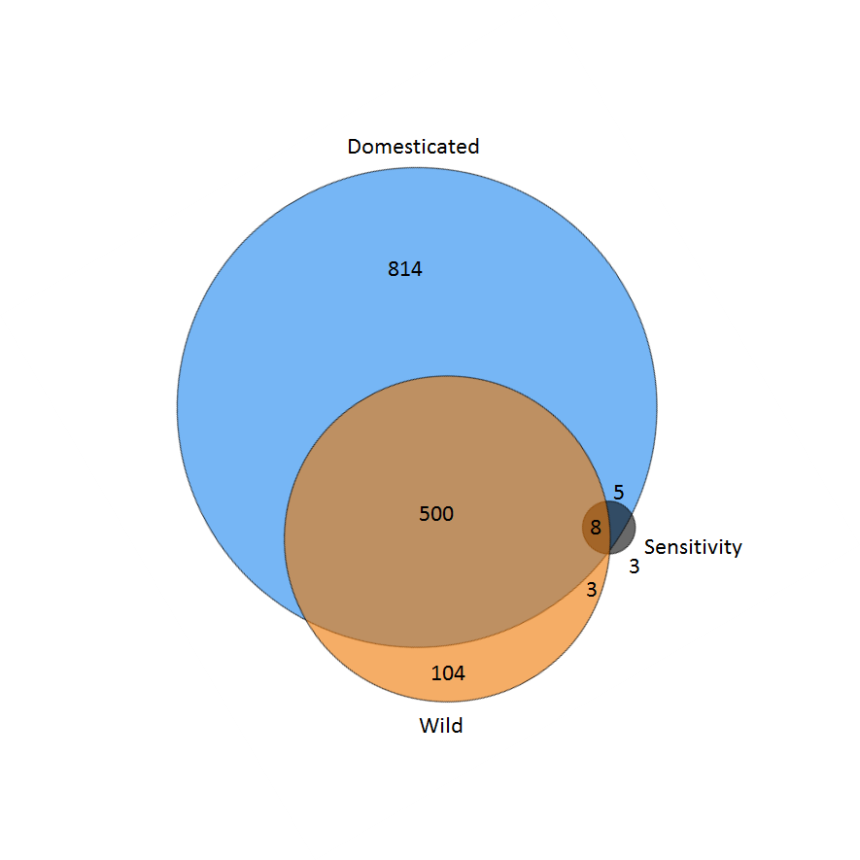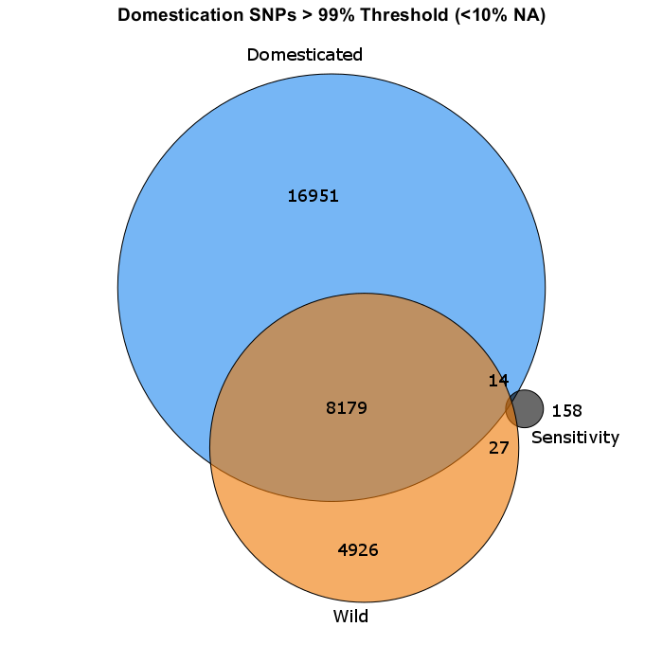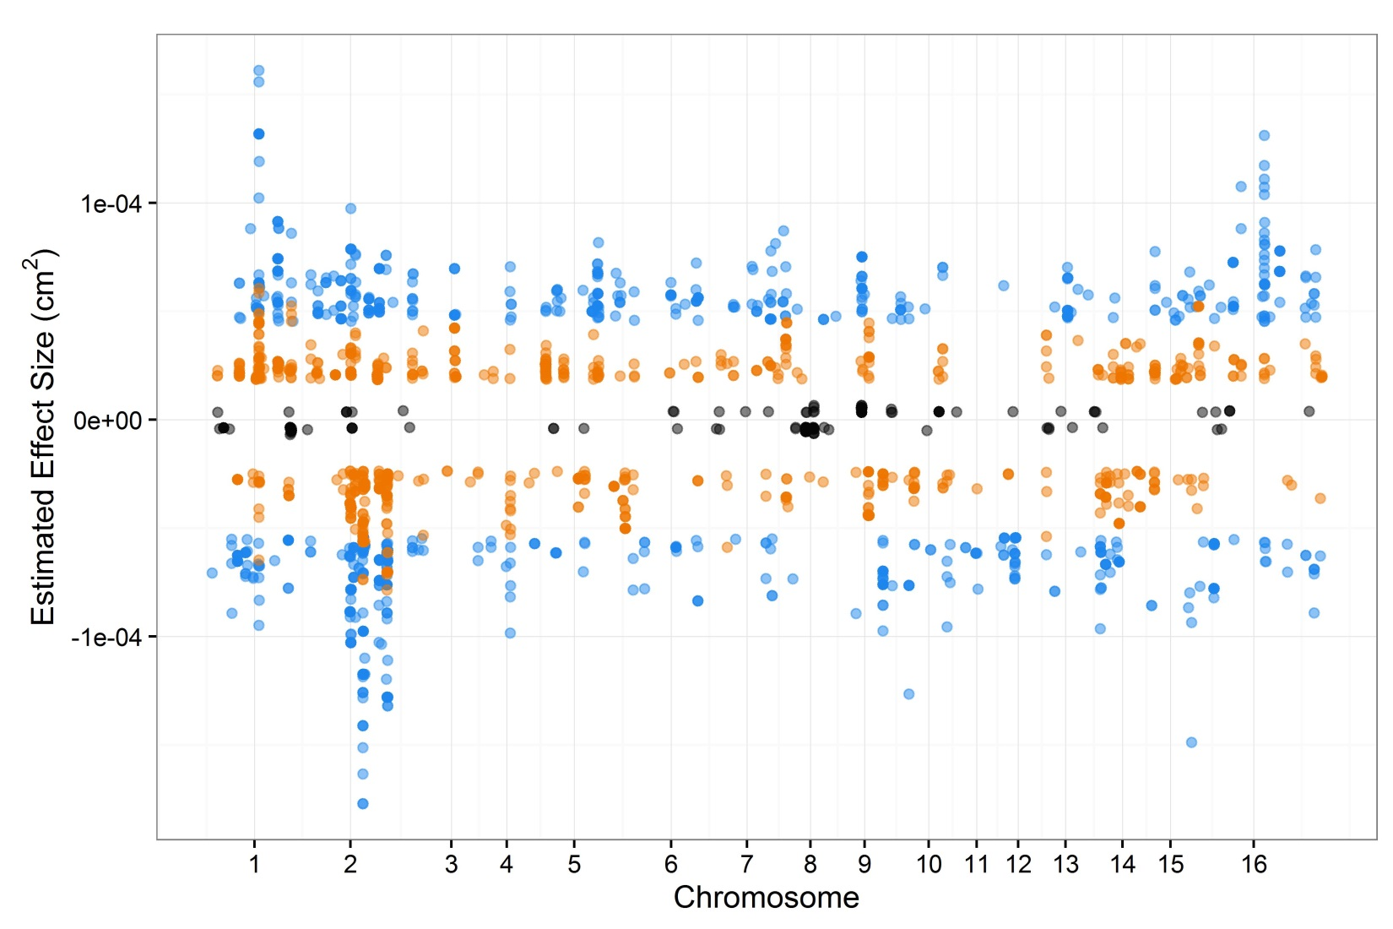

**a**

**b**

**c**

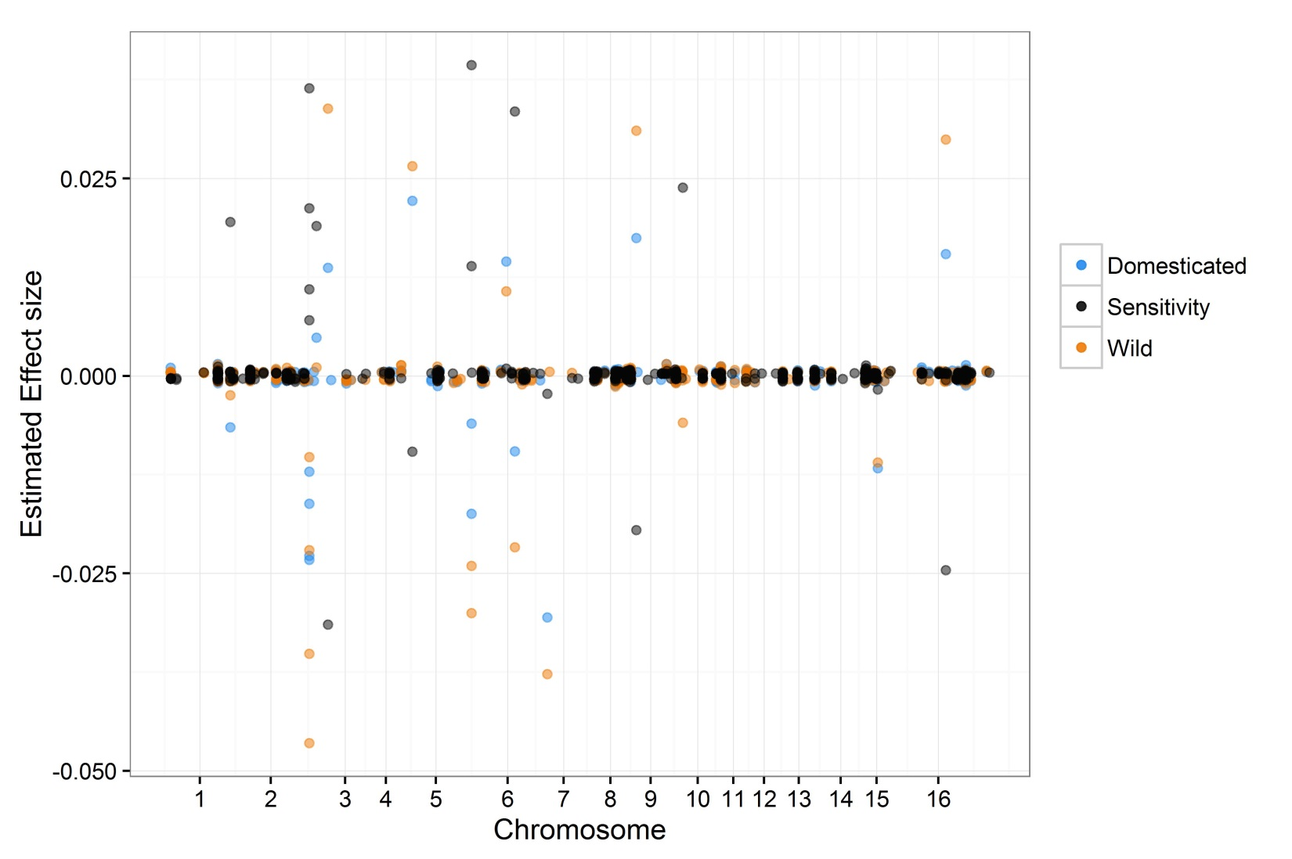

**Figure 7. GWA analysis of domestication sensitivity in *B. cinerea*.**

Domestication sensitivity of each isolate was estimated using the average virulence on the wild and domesticated tomato germplasm and using calculated Sensitivity. This was then utilized for GWA mapping by bigRR.

a) The top 1000 SNPs that significantly affect lesion size across domesticated tomato, wild tomato or domestication sensitivity are shown. Significance is called as crossing the 99% permutation threshold.

b) Venn diagram of overlapping SNPs identified as crossing the 99% permutation threshold for each trait.

c) Venn diagram of overlapping genes identified as crossing the 99% permutation threshold for each trait. Genes were called as significant if there was one significant SNP within the gene body or within 2kb of the gene body.

**DISCUSSION**

The genetics of plant resistance to generalist pathogens are mostly quantitative, depend upon pathogen isolate, and rely on genetic variation in both signal perception and direct defense genes (Kover and Schaal 2002, Parlevliet 2002, Glazebrook 2005, Nomura, Melotto et al. 2005, Goss and Bergelson 2006, Tiffin and Moeller 2006, Rowe and Kliebenstein 2008, Barrett, Kniskern et al. 2009, Corwin, Copeland et al. 2016). Previous studies on tomato resistance to *B. cinerea* have found a quantitative genetic architecture that varies between domesticated and wild tomato species, with higher resistance in the wild species (Egashira, Kuwashima et al. 2000, Nicot, Moretti et al. 2002, Guimaraes, Chetelat et al. 2004, Finkers, van Heusden et al. 2007, Ten Have, van Berloo et al. 2007, Finkers, Bai et al. 2008). However, it was not known how the choice of *B. cinerea* isolate may change this plant-pathogen interaction. To address these questions, we used genetic variation in wild and domesticated tomato accessions in conjunction with a population of *B. cinerea* isolates. This also allowed us to test how domestication within tomato influenced the interaction at the level of the pathogen population and individual genes in the pathogen. *B. cinerea* virulence on tomato, as measured by lesion size, was significantly affected by pathogen isolate, host genotype, and domestication status (Table 1). Tomato domestication led to a slight but significant decrease in resistance to the pathogen but critically, there was no evidence of a domestication bottleneck, with similar variance in resistance between the wild and domesticated tomato accessions (Table 1, Figure 2). There was also little evidence in this *B. cinerea* population for specialization to tomato, supporting the hypothesis that *B. cinerea* is a generalist at the isolate and species level (Figure 1 c-h) (Giraud, Fortini et al. 1999, Martinez, Blancard et al. 2003, Ma and Michailides 2005). GWA mapping within the pathogen showed that the genetics underlying *B. cinerea* virulence on tomato are highly quantitative and vary across tomato genotypes and domestication status (Figure 5, Figure 7). This analysis identified a small subset of pathogen genes whose variation contributes to differential virulence on most of the hosts tested, and a set of pathogen genes whose variation is responsive to tomato domestication (Table S2b, d, f). We also identified a conservative subset of genes whose association to differential *Botrytis cinerea* virulence is insensitive to GWA method and reference genome (Table S2 a, b, c, d).

**Domestication and altered pathogen virulence genetics**

These results provide evidence of a mild tomato domestication effect on resistance to the generalist pathogen, *B. cinerea.* We measured an 18% increase in susceptibility across domesticated varieties, but this represents less than 1% of the total variance of *B. cinerea* lesion size on tomato (Table 1). As such, domestication status alone is a poor predictor of a specific tomato host’s resistance to infection by *B. cinerea*. This suggests that while tomato domestication does affect this plant-pathogen interaction, it is not the primary factor defining the measured trait. The effect of tomato domestication varied across the *B. cinerea* isolates, with specific loci linked to differential virulence across wild and domestic tomatoes (Figure 1 c-h). If a study relies on one or a few isolates, it could obtain a falsely high or falsely low estimation of how host domestication influences pathogen resistance. This shows the need to utilize a population of *B. cinerea* to understand the factors contributing to *B. cinerea* virulence and how this is altered by crop domestication.

In biotrophic pathogens, host domestication has decreased the diversity of resistance alleles because they are lost in the domestication bottleneck as found for specialist pathogens (Tanksley and McCouch 1997, Doebley, Gaut et al. 2006, Hyten, Song et al. 2006, Chaudhary 2013). Surprisingly, we did not find evidence for a domestication bottleneck in the phenotypic resistance to *B. cinerea* (Figure 2, Figure 3). This is in contrast to genomic studies that explicitly show a genotypic bottleneck within tomato domestication (Miller and Tanksley 1990, Koenig, Jiménez-Gómez et al. 2013). This suggests that at least for this generalist pathogen, the genetic bottleneck of tomato domestication has not imparted a phenotypic bottleneck. One possible explanation is that resistance to this pathogen is so polygenic in the plant that our experiment is not sufficiently large to pick up any genetic bottleneck effect using phenotypic variance. These patterns, of mild decrease in resistance to *B. cinerea* due to plant domestication, and within-species plant variation exceeding the contribution of domestication itself, may be unique to interactions between *B. cinerea* and tomato, or more general. It remains to be seen if these patterns hold for *B. cinerea* on its other host plants. It is unclear whether domestication has a universal effect on plant resistance to *B. cinerea*, or if each domestication event is unique.

**Polygenic quantitative virulence and breeding complications**

Our results indicate a highly polygenic basis of quantitative virulence of the generalist *B. cinerea* on tomato. The variation in lesion size is linked to numerous *B. cinerea* SNPs, each with small effect sizes (Figure 4a). Importantly, the tomato host accession greatly influenced which *B. cinerea* loci were significantly associated to lesion size (Figure 5). Thus, it possible that there is specialization at the gene level, in which different alleles within the pathogen link to differential virulence on specific host genotypes (Giraud, Fortini et al. 1999, Rowe and Kliebenstein 2007, Blanco-Ulate, Morales-Cruz et al. 2014). This polygenic architecture of virulence is distinctly different from specialist pathogens that often have one or a few large effect genes that control virulence (Keen 1992, De Feyter, Yang et al. 1993, Abramovitch and Martin 2004, Boyd, Ridout et al. 2013, Vleeshouwers and Oliver 2014). Further studies are needed to compare how the host plant species may affect this image of genetic variation in virulence.

These results indicate particular challenges for breeding durable resistance to *B. cinerea*, and possibly other generalist pathogens. The highly polygenic variation in virulence, combined with genomic sequencing showing that this pathogen is an inter-breeding population, suggests that the pathogen is actively blending a large collection of polymorphic virulence loci (Rowe and Kliebenstein 2007, Fekete, Fekete et al. 2012, Atwell, Corwin et al. 2015, Atwell, Soltis et al. 2017). Thus, it is not sufficient to breed crop resistance against a single isolate of *B. cinerea*, as this resistance mechanism would likely be rapidly overcome by new genotypes within the field population of *B. cinerea*. In contrast, it is likely necessary to breed resistance using a population of the pathogen, and to focus on plant loci that target entire virulence pathways or mechanisms. The results in this study indicate that the specific genetics of the plant host, the general domestication status, and the specific genetics of the pathogen isolate will all combine to affect how the estimated breeding value inferred from any experiment will translate to a field application (Table 1). As such, utilizing a single or even a few pathogen isolates to guide resistance breeding in plants is unlikely to translate to durable resistance against *B. cinerea* as a species. Further, the lack of a domestication bottleneck on tomato resistance to B*. cinerea* suggests that, at least for tomato, allelic variation in this generalist pathogen is sufficient to overcome introgression of wild resistance genes or alleles into the domesticated crop.

**Conclusion**

This study examined the contributions of host and pathogen natural genetic variation to the quantitative interaction in the tomato-*B. cinerea* pathosystem. In addition, the study explicitly tested the effects of tomato domestication on this pathosystem. *B. cinerea* has a highly quantitative genetic basis of virulence on tomato, which is dominated by pathogen effects but also sensitive to genetic variation linked to tomato domestication. Future studies are necessary to test if this pattern of domestication responses in tomato is similar to patterns in other crops. Because this population of *B. cinerea* can infect a wide range of hosts, it will be possible to directly conduct this study. By extending future work to additional domestication events, it may be possible to test whether independent crop domestication events have a consistent underlying genetic signal of *B. cinerea* adaptation to plant domestication.

**Methods**

**Tomato genetic resources**

We obtained seeds for 12 selected tomato genotypes in consultation with the UC Davis Tomato Genetics Resource Center. These include a diverse sample of 6 genotypes of domesticated tomato’s closest wild relative (*S. pimpinellifolium*) sampling across its major geographic regions (Peru, Ecuador) and 6 heritage and modern varieties of *S. lycopersicum*, focusing on mid- to late-20th century improved varieties (Lin, Zhu et al. 2014, Blanca, Montero-Pau et al. 2015). While genetic data is not available for all of our *S. pimpinellifolium* accessions, 9 of the 12 accessions have been genotyped and span the mappable diversity in domesticated tomato and its close relatives (Sim, Durstewitz et al. 2012) (Figure S1). We bulked all genotypes in long-day (16h photoperiod) greenhouse conditions at UC Davis in fall 2014. We grew plants under metal-halide lamps using day/night temperatures at 25°C/18°C in 4” pots filled with standard potting soil (Sunshine mix #1, Sun Gro Horticulture). Plants were watered once daily and pruned and staked to maintain upright growth. Fruits were collected at maturity and stored at 4°C in dry paper bags until seed cleaning. To clean the seeds, we incubated seeds and locule contents at 24°C in 1% protease solution (Rapidase C80 Max) for 2h, then rinsed them in deionized water and air-dried. We then stored seeds in a cool, dry, dark location until use.

To grow plants for detached leaf assays, we bleach-sterilized all seeds and germinated them on paper in the growth chamber using flats covered with humidity domes. At 7 days we transferred seedlings to soil (SunGro Horticulture, Agawam, MA) and grew all plants in growth chambers in 20°C, short-day (10h photoperiod) conditions with 180-190 uM light intensity and 60% RH. We bottom-watered with deionized water every two days for two weeks, and at week 3 watered every two days with added nutrient solution (0.5% N-P-K fertilizer in a 2-1- 2 ratio; Grow More 4-18-38). The plants were used for detached leaf assays 6 weeks after transferring seedlings to soil. Flowering in this system did not occur until minimally 9 weeks of age for any accession, and as such we were sampling midway between the juvenile/adult transition and any flowering time decision. This window has been successful to minimize any major ontogenetic effects on the pathogen/host interaction in other systems (Corwin, Copeland et al. 2016).

***B. cinerea* genetic resources**

We utilized a previously described collection of *B. cinerea* isolates that were isolated as single spores from natural infections of fruit and vegetable tissues collected in California and internationally (Atwell, Corwin et al. 2015, Zhang, Corwin et al. 2017). This included five isolates obtained from natural infections of tomato. We maintained *B. cinerea* isolates as conidial suspensions in 30% glycerol for long-term storage at -80°C. For regrowth, we diluted spore solutions to 10% concentration in filter-sterilized 50% grape juice, and then inoculated onto 39g/L potato dextrose agar (PDA) media. We grew isolates at 25°C in 12h light and propagated every 2 weeks. Sequencing failed for 6 out of our 97 phenotyped isolates. For bigRR GWA mapping with the 91 isolates genotyped in this study, we utilized a total of 272,672 SNPs against the *B. cinerea* T4 genome with minor allele frequency (MAF) 0.20 or greater, and less than 10% missing calls across the isolates (SNP calls in at least 82/ 91 isolates). For GEMMA mapping, we used 91 isolates with a total of 237,878 SNPs against the *B. cinerea* B05.10 genome with MAF 0.20 or greater and less than 10% missing calls. The overall SNP number was similar when using either reference genome.

**Detached leaf assay**

To study the effect of genetic variation in host and pathogen on lesion formation, we infected detached leaves of 12 diverse tomato varieties with the above 97 *B. cinerea* isolates. We used a randomized complete block design for a total of 6 replicates across 2 experiments. In each experiment, this included a total of 10 plants per genotype randomized in 12 flats in 3 growth chambers. Each growth chamber block corresponded with a replicate of the detached leaf assay, such that growth chamber and replicate shared the same environmental block. At 6 weeks of age, we selected 5 leaves per plant (expanded leaves from second true leaf or younger), and 2 leaflet pairs per leaf. We randomized the order of leaves from each plant, and the leaflets were placed on 1% phytoagar in planting flats, with humidity domes. Our inoculation protocol followed previously described methods (Denby, Kumar et al. 2004, Kliebenstein, Rowe et al. 2005). Spores were collected from mature *B. cinerea* cultures grown on canned peach plates and diluted to 10 spores/ µL in filter-sterilized 50% organic grape juice. Spores in grape juice were maintained in 4°C refrigeration or on ice from the time of collection, to inhibit germination prior to inoculation. The diluted spore suspensions were homogenized by agitation continuously during the entire process of applying the spores to all samples. This maintains the spores in the suspension and ensures even application across samples, then 4µl droplets were placed onto the detached leaflets at room temperature. The entire inoculation took approximately 2 hour of time per experiment. Mock-inoculated control leaves were treated with 4µL of 50% organic grape juice without spores. Digital photos were taken of all leaflets at 24, 48, and 72 hours post inoculation and automated image analysis was used to measure lesion size.

**Automated Image Analysis**

Lesion area was digitally measured using the EBImage and CRImage packages (Pau, Fuchs et al. 2010, Failmezger, Yuan et al. 2012) in the R statistical environment (R Development Core Team 2008), as previously described (Corwin, Copeland et al. 2016, Corwin, Subedy et al. 2016). Leaflets were identified as objects with green hue, and lesions were identified as low-saturation objects within leaves. Images masks were generated for both the leaf and lesion, then manually refined by a technician to ensure accurate object calling. The area of these leaves and lesions were then automatically measured as pixels per lesion and converted to area using a 1 cm reference within each image.

**Data analysis**

We analyzed lesion areas using a general linear model for the full experiment, including the fixed effects of isolate genotype, plant domestication (*S. lycopersicum* or *S. pimpinellifolium*), plant genotype (which is nested within domestication status), experiment, and block (nested within experiment) on lesion area, as well as their interactions (R lme4 package; (Bates, Maechler et al. 2015)). Two of our 97 isolates that did not have replication across 2 experiments were dropped at this stage of analysis. There was no difference in the results if experiment and block were treated as random effects. Adding terms for individual plant, leaf, and leaflet position did not significantly improve the full model, so they were omitted from further analysis. We also tested a mixed model with random effects of experiment and block, but this did not affect our interpretation of the fixed effects. This model was used to calculate the significance of each factor and to obtain the least-squared means of lesion size for each *B. cinerea* isolate x tomato accession as well as for each *B. cinerea* isolate x domestic/wild tomato. We also calculated a domestication sensitivity phenotype, Sensitivity = (Domesticated lesion size – Wild lesion size) / Domesticated lesion size.

Using tomato sequence data from the SolCAP diversity panel that contained 9 of our 12 accessions, we determined pairwise genetic distances (Sim, Durstewitz et al. 2012). We calculated pairwise Euclidean distances between 426 wild and domesticated tomato accessions from Infinium SNP genotyping at 7,720 loci using the R adegenet package (Jombart , Sim, Durstewitz et al. 2012). Clustering is by R hclust (in the stats package) default UPGMA method (R Development Core Team 2008).

We used several methods to examine host specialization to tomato within *B. cinerea*. First, we split our *B. cinerea* population into isolates collected from tomato tissue vs. other hosts. We compared these groups by t-test for virulence on domesticated tomato genotypes, wild tomato genotypes, or all tomato genotypes. Next, we used a Wilcoxon signed-rank test to compare the rank order distribution of lesion sizes across paired tomato genotypes. To examine host specialization to tomato domestication within *B. cinerea*, we used a Wilcoxon signed-rank test to compare the rank order of lesion sizes across all domesticated vs. all wild tomato genotypes. Finally, we conducted single-isolate ANOVAs with FDR correction to identify isolates with a significant response to plant genotype or domestication status.

The model means and Domestication Sensitivity were used as the phenotypic input for GWA using bigRR, a heteroskedastic ridge regression method that incorporates SNP-specific shrinkage (Shen, Alam et al. 2013). This approach has previously had a high validation rate (Ober, Huang et al. 2015, Corwin, Copeland et al. 2016, Francisco, Joseph et al. 2016, Kooke, Kruijer et al. 2016). The *B. cinerea* bigRR GWA used 272,672 SNPs at MAF 0.20 or greater and <10% missing SNP calls as described above. Because bigRR provides an estimated effect size, but not a p-value, significance was estimated using 1000 permutations to determine effect significance at 95%, 99%, and 99.9% thresholds (Doerge and Churchill 1996, Shen, Alam et al. 2013, Corwin, Copeland et al. 2016). SNPs were annotated by custom R scripts with gene transfer format file construction from the T4 gene models for genomic DNA by linking the SNP to genes within a 2kbp window ([http://www.broadinstitute.org](http://www.broadinstitute.org/), (Staats and van Kan 2012)). Functional annotations are based on the T4 gene models for genomic DNA (http://www.broadinstitute.org, *B. cinerea*; (Staats and van Kan 2012)). Additional genes of interest, based on a broad literature search of known virulence loci, were taken from NCBI (https://www.ncbi.nlm.nih.gov/) and included by mapping sequence to the T4 reference using MUMmer v3.0 (Kurtz, Phillippy et al. 2004).

To predict expected overlap of significant SNPs across plant genotypes, we used the average number of significant SNPs per each of the 12 plant genotypes (14,000 SNPs) and calculated expected overlap between those 12 lists using binomial coefficients.The *B. cinerea* GEMMA used 237,878 SNPs at MAF 0.20 or greater, and less than 10% missing SNP calls as described above. To determine significance of SNPs by GEMMA, we used 1000 permutations to determine p-value significance at the 99%, and 99.9% thresholds (Doerge and Churchill 1996, Shen, Alam et al. 2013, Corwin, Copeland et al. 2016). SNPs were annotated using a custom R script linking the SNP to genes within a 2kbp window from the gene transfer format file construction from the B05.10 gene models for genomic DNA (Staats and van Kan 2012, Zerbino, Achuthan et al. 2017). A table of gene name translations across genome annotations was pulled from the gene overlap between the bigRR T4 annotation and GEMMA B05.10 annotation using a custom R script and gene name translations pulled from the INRA *Botrytis cinerea* Portal (Choquer, Fournier et al. 2007, Viaud, Adam-Blondon et al. 2012). Functional annotations of the overlap lists are based on the T4 gene models for genomic DNA (http://www.broadinstitute.org, *B. cinerea*; (Staats and van Kan 2012).

**References**

Abramovitch, R. B. and G. B. Martin (2004). "Strategies used by bacterial pathogens to suppress plant defenses." Current opinion in plant biology **7**(4): 356-364.

AbuQamar, S., M.-F. Chai, H. Luo, F. Song and T. Mengiste (2008). "Tomato protein kinase 1b mediates signaling of plant responses to necrotrophic fungi and insect herbivory." The Plant Cell **20**(7): 1964-1983.

Atwell, S., J. Corwin, N. Soltis, A. Subedy, K. Denby and D. J. Kliebenstein (2015). "Whole genome resequencing of Botrytis cinerea isolates identifies high levels of standing diversity." Frontiers in microbiology **6**: 996.

Atwell, S., N. Soltis and D. J. Kliebenstein (2017). "Genetic Diversity in 97 Botrytis cinerea Isolates." in prep.

Bai, Y. and P. Lindhout (2007). "Domestication and breeding of tomatoes: what have we gained and what can we gain in the future?" Annals of botany **100**(5): 1085-1094.

Ballaré, C. L. and R. Pierik (2017). "The shade‐avoidance syndrome: multiple signals and ecological consequences." Plant, cell & environment **40**(11): 2530-2543.

Barrett, L. G. and M. Heil (2012). "Unifying concepts and mechanisms in the specificity of plant–enemy interactions." Trends in plant science **17**(5): 282-292.

Barrett, L. G., J. M. Kniskern, N. Bodenhausen, W. Zhang and J. Bergelson (2009). "Continua of specificity and virulence in plant host–pathogen interactions: causes and consequences." New Phytologist **183**(3): 513-529.

Bartoli, C. and F. Roux (2017). "Genome-Wide Association Studies In Plant Pathosystems: Toward an Ecological Genomics Approach." Frontiers in plant science **8**.

Bates, D., M. Maechler, B. Bolker and S. Walker (2015). "Fitting Linear Mixed-Effects Models Using lme4." Journal of Statistical Software **67**(1): 1-48.

Bergougnoux, V. (2014). "The history of tomato: from domestication to biopharming." Biotechnology advances **32**(1): 170-189.

Bhardwaj, V., S. Meier, L. N. Petersen, R. A. Ingle and L. C. Roden (2011). "Defence responses of Arabidopsis thaliana to infection by Pseudomonas syringae are regulated by the circadian clock." PloS one **6**(10): e26968.

Bittel, P. and S. Robatzek (2007). "Microbe-associated molecular patterns (MAMPs) probe plant immunity." Current opinion in plant biology **10**(4): 335-341.

Blanca, J., J. Montero-Pau, C. Sauvage, G. Bauchet, E. Illa, M. J. Díez, D. Francis, M. Causse, E. van der Knaap and J. Cañizares (2015). "Genomic variation in tomato, from wild ancestors to contemporary breeding accessions." BMC genomics **16**(1): 257.

Blanco-Ulate, B., A. Morales-Cruz, K. C. Amrine, J. M. Labavitch, A. L. Powell and D. Cantu (2014). "Genome-wide transcriptional profiling of Botrytis cinerea genes targeting plant cell walls during infections of different hosts." Frontiers in plant science **5**.

Boller, T. and S. Y. He (2009). "Innate immunity in plants: an arms race between pattern recognition receptors in plants and effectors in microbial pathogens." Science **324**(5928): 742-744.

Boyd, L. A., C. Ridout, D. M. O'Sullivan, J. E. Leach and H. Leung (2013). "Plant–pathogen interactions: disease resistance in modern agriculture." Trends in genetics **29**(4): 233-240.

Camañes, G., L. Scalschi, B. Vicedo, C. González‐Bosch and P. García‐Agustín (2015). "An untargeted global metabolomic analysis reveals the biochemical changes underlying basal resistance and priming in Solanum lycopersicum, and identifies 1‐methyltryptophan as a metabolite involved in plant responses to Botrytis cinerea and Pseudomonas syringae." The Plant Journal **84**(1): 125-139.

Campos, M. L., Y. Yoshida, I. T. Major, D. de Oliveira Ferreira, S. M. Weraduwage, J. E. Froehlich, B. F. Johnson, D. M. Kramer, G. Jander and T. D. Sharkey (2016). "Rewiring of jasmonate and phytochrome B signalling uncouples plant growth-defense tradeoffs." Nature communications **7**: 12570.

Cerveny, L., A. Straskova, V. Dankova, A. Hartlova, M. Ceckova, F. Staud and J. Stulik (2013). "Tetratricopeptide repeat motifs in the world of bacterial pathogens: role in virulence mechanisms." Infection and immunity **81**(3): 629-635.

Chaudhary, B. (2013). "Plant domestication and resistance to herbivory." International journal of plant genomics **2013**.

Chen, W., X. Liang, A. J. Peterson, D. H. Munn and B. R. Blazar (2008). "The indoleamine 2, 3-dioxygenase pathway is essential for human plasmacytoid dendritic cell-induced adaptive T regulatory cell generation." The Journal of Immunology **181**(8): 5396-5404.

Choquer, M., E. Fournier, C. Kunz, C. Levis, J.-M. Pradier, A. Simon and M. Viaud (2007). "Botrytis cinerea virulence factors: new insights into a necrotrophic and polyphageous pathogen." FEMS microbiology letters **277**(1): 1-10.

Corwin, J. A., D. Copeland, J. Feusier, A. Subedy, R. Eshbaugh, C. Palmer, J. Maloof and D. J. Kliebenstein (2016). "The quantitative basis of the Arabidopsis innate immune system to endemic pathogens depends on pathogen genetics." PLoS Genet **12**(2): e1005789.

Corwin, J. A., A. Subedy, R. Eshbaugh and D. J. Kliebenstein (2016). "Expansive phenotypic landscape of Botrytis cinerea shows differential contribution of genetic diversity and plasticity." Molecular Plant-Microbe Interactions **29**(4): 287-298.

Couch, B. C., I. Fudal, M.-H. Lebrun, D. Tharreau, B. Valent, P. Van Kim, J.-L. Nottéghem and L. M. Kohn (2005). "Origins of host-specific populations of the blast pathogen Magnaporthe oryzae in crop domestication with subsequent expansion of pandemic clones on rice and weeds of rice." Genetics **170**(2): 613-630.

Dalmais, B., J. Schumacher, J. Moraga, P. Le Pecheur, B. Tudzynski, I. G. Collado and M. Viaud (2011). "The Botrytis cinerea phytotoxin botcinic acid requires two polyketide synthases for production and has a redundant role in virulence with botrydial." Molecular plant pathology **12**(6): 564-579.

Dalman, K., K. Himmelstrand, Å. Olson, M. Lind, M. Brandström-Durling and J. Stenlid (2013). "A genome-wide association study identifies genomic regions for virulence in the non-model organism Heterobasidion annosum ss." PLoS One **8**(1): e53525.

Dangl, J. L. and J. D. Jones (2001). "Plant pathogens and integrated defence responses to infection." nature **411**(6839): 826-833.

De Feyter, R., Y. Yang and D. W. Gabriel (1993). "Gene-for-genes interactions between cotton R genes and Xanthomonas campestris pv. malvacearum avr genes." Molecular plant-microbe interactions: MPMI **6**(2): 225-237.

Dean, R., J. A. Van Kan, Z. A. Pretorius, K. E. Hammond‐Kosack, A. Di Pietro, P. D. Spanu, J. J. Rudd, M. Dickman, R. Kahmann and J. Ellis (2012). "The Top 10 fungal pathogens in molecular plant pathology." Molecular plant pathology **13**(4): 414-430.

Deighton, N., I. Muckenschnabel, A. J. Colmenares, I. G. Collado and B. Williamson (2001). "Botrydial is produced in plant tissues infected by Botrytis cinerea." Phytochemistry **57**(5): 689-692.

Denby, K. J., P. Kumar and D. J. Kliebenstein (2004). "Identification of Botrytis cinerea susceptibility loci in Arabidopsis thaliana." The Plant Journal **38**(3): 473-486.

Desjardins, C. A., K. A. Cohen, V. Munsamy, T. Abeel, K. Maharaj, B. J. Walker, T. P. Shea, D. V. Almeida, A. L. Manson and A. Salazar (2016). "Genomic and functional analyses of Mycobacterium tuberculosis strains implicate ald in D-cycloserine resistance." Nature genetics **48**(5): 544-551.

Dıaz, J., A. ten Have and J. A. van Kan (2002). "The role of ethylene and wound signaling in resistance of tomato to Botrytis cinerea." Plant physiology **129**(3): 1341-1351.

Dodds, P. N. and J. P. Rathjen (2010). "Plant immunity: towards an integrated view of plant–pathogen interactions." Nature Reviews Genetics **11**(8): 539-548.

Doebley, J. F., B. S. Gaut and B. D. Smith (2006). "The molecular genetics of crop domestication." Cell **127**(7): 1309-1321.

Doerge, R. W. and G. A. Churchill (1996). "Permutation tests for multiple loci affecting a quantitative character." Genetics **142**(1): 285-294.

Dwivedi, S. L., H. D. Upadhyaya, H. T. Stalker, M. W. Blair, D. J. Bertioli, S. Nielen and R. Ortiz (2008). "Enhancing crop gene pools with beneficial traits using wild relatives." Plant Breeding Reviews **30**: 179.

Egashira, H., A. Kuwashima, H. Ishiguro, K. Fukushima, T. Kaya and S. Imanishi (2000). "Screening of wild accessions resistant to gray mold (Botrytis cinerea Pers.) in Lycopersicon." Acta physiologiae plantarum **22**(3): 324-326.

Elad, Y., B. Williamson, P. Tudzynski and N. Delen (2007). Botrytis spp. and diseases they cause in agricultural systems–an introduction. Botrytis: Biology, pathology and control, Springer**:** 1-8.

Failmezger, H., Y. Yuan, O. Rueda, F. Markowetz and M. H. Failmezger (2012). "CRImage: CRImage a package to classify cells and calculate tumour cellularity." R package version 1.24.0.

Farhat, M. R., B. J. Shapiro, K. J. Kieser, R. Sultana, K. R. Jacobson, T. C. Victor, R. M. Warren, E. M. Streicher, A. Calver and A. Sloutsky (2013). "Genomic analysis identifies targets of convergent positive selection in drug-resistant Mycobacterium tuberculosis." Nature genetics **45**(10): 1183-1189.

Fekete, É., E. Fekete, L. Irinyi, L. Karaffa, M. Árnyasi, M. Asadollahi and E. Sándor (2012). "Genetic diversity of a Botrytis cinerea cryptic species complex in Hungary." Microbiological Research **167**(5): 283-291.

Ferrari, S., R. Galletti, C. Denoux, G. De Lorenzo, F. M. Ausubel and J. Dewdney (2007). "Resistance to Botrytis cinerea induced in Arabidopsis by elicitors is independent of salicylic acid, ethylene, or jasmonate signaling but requires PHYTOALEXIN DEFICIENT3." Plant physiology **144**(1): 367-379.

Ferrari, S., J. M. Plotnikova, G. De Lorenzo and F. M. Ausubel (2003). "Arabidopsis local resistance to Botrytis cinerea involves salicylic acid and camalexin and requires EDS4 and PAD2, but not SID2, EDS5 or PAD4." The Plant Journal **35**(2): 193-205.

Fillinger, S. and Y. Elad (2015). Botrytis-the Fungus, the Pathogen and Its Management in Agricultural Systems, Springer.

Finkers, R., Y. Bai, P. van den Berg, R. van Berloo, F. Meijer-Dekens, A. Ten Have, J. van Kan, P. Lindhout and A. W. van Heusden (2008). "Quantitative resistance to Botrytis cinerea from Solanum neorickii." Euphytica **159**(1-2): 83-92.

Finkers, R., A. W. van Heusden, F. Meijer-Dekens, J. A. van Kan, P. Maris and P. Lindhout (2007). "The construction of a Solanum habrochaites LYC4 introgression line population and the identification of QTLs for resistance to Botrytis cinerea." Theoretical and Applied Genetics **114**(6): 1071-1080.

Francisco, M., B. Joseph, H. Caligagan, B. Li, J. A. Corwin, C. Lin, R. E. Kerwin, M. Burow and D. J. Kliebenstein (2016). "Genome wide association mapping in Arabidopsis thaliana identifies novel genes involved in linking allyl glucosinolate to altered biomass and defense." Frontiers in plant science **7**.

Gao, Y., Z. Liu, J. D. Faris, J. Richards, R. S. Brueggeman, X. Li, R. P. Oliver, B. A. McDonald and T. L. Friesen (2016). "Validation of genome-wide association studies as a tool to identify virulence factors in Parastagonospora nodorum." Phytopathology **106**(10): 1177-1185.

Giraud, T., D. Fortini, C. Levis, C. Lamarque, P. Leroux, K. LoBuglio and Y. Brygoo (1999). "Two sibling species of the Botrytis cinerea complex, transposa and vacuma, are found in sympatry on numerous host plants." Phytopathology **89**(10): 967-973.

Glazebrook, J. (2005). "Contrasting mechanisms of defense against biotrophic and necrotrophic pathogens." Annu. Rev. Phytopathol. **43**: 205-227.

Goss, E. M. and J. Bergelson (2006). "Variation in resistance and virulence in the interaction between Arabidopsis thaliana and a bacterial pathogen." Evolution **60**(8): 1562-1573.

Guimaraes, R. L., R. T. Chetelat and H. U. Stotz (2004). "Resistance to Botrytis cinerea in Solanum lycopersicoides is dominant in hybrids with tomato, and involves induced hyphal death." European journal of plant pathology **110**(1): 13-23.

Hacquard, S., B. Kracher, T. Maekawa, S. Vernaldi, P. Schulze-Lefert and E. V. L. van Themaat (2013). "Mosaic genome structure of the barley powdery mildew pathogen and conservation of transcriptional programs in divergent hosts." Proceedings of the National Academy of Sciences **110**(24): E2219-E2228.

Hahn, M. (2014). "The rising threat of fungicide resistance in plant pathogenic fungi: Botrytis as a case study." Journal of chemical biology **7**(4): 133-141.

Harren, K., B. Brandhoff, M. Knödler and B. Tudzynski (2013). "The high-affinity phosphodiesterase BcPde2 has impact on growth, differentiation and virulence of the phytopathogenic ascomycete Botrytis cinerea." PLOS one **8**(11): e78525.

Hevia, M. A., P. Canessa, H. Müller-Esparza and L. F. Larrondo (2015). "A circadian oscillator in the fungus Botrytis cinerea regulates virulence when infecting Arabidopsis thaliana." Proceedings of the National Academy of Sciences **112**(28): 8744-8749.

Hyten, D. L., Q. Song, Y. Zhu, I.-Y. Choi, R. L. Nelson, J. M. Costa, J. E. Specht, R. C. Shoemaker and P. B. Cregan (2006). "Impacts of genetic bottlenecks on soybean genome diversity." Proceedings of the National Academy of Sciences **103**(45): 16666-16671.

Izquierdo‐Bueno, I., V. E. González‐Rodríguez, A. Simon, B. Dalmais, J. M. Pradier, P. Le Pêcheur, A. Mercier, A. S. Walker, C. Garrido and I. G. Collado (2018). "Biosynthesis of abscisic acid in fungi: Identification of a sesquiterpene cyclase as the key enzyme in Botrytis cinerea." Environmental microbiology.

Jombart, T. (2008). "adegenet: a R package for the multivariate analysis of genetic markers." Bioinformatics **24**(11): 1403-1405.

Jones, J. D. and J. L. Dangl (2006). "The plant immune system." Nature **444**(7117): 323-329.

Katan, T. (1999). "Current status of vegetative compatibility groups in Fusarium oxysporum." Phytoparasitica **27**(1): 51-64.

Keen, N. (1992). "The molecular biology of disease resistance." Plant molecular biology **19**(1): 109-122.

Kliebenstein, D. J., H. C. Rowe and K. J. Denby (2005). "Secondary metabolites influence Arabidopsis/Botrytis interactions: variation in host production and pathogen sensitivity." The Plant Journal **44**(1): 25-36.

Koenig, D., J. M. Jiménez-Gómez, S. Kimura, D. Fulop, D. H. Chitwood, L. R. Headland, R. Kumar, M. F. Covington, U. K. Devisetty and A. V. Tat (2013). "Comparative transcriptomics reveals patterns of selection in domesticated and wild tomato." Proceedings of the National Academy of Sciences **110**(28): E2655-E2662.

Kooke, R., W. Kruijer, R. Bours, F. F. Becker, A. Kuhn, J. Buntjer, T. Doeswijk, J. Guerra, H. J. Bouwmeester and D. Vreugdenhil (2016). "Genome-wide association mapping and genomic prediction elucidate the genetic architecture of morphological traits in Arabidopsis thaliana." Plant Physiology: pp. 00997.02015.

Kover, P. X. and B. A. Schaal (2002). "Genetic variation for disease resistance and tolerance among Arabidopsis thaliana accessions." Proceedings of the National Academy of Sciences **99**(17): 11270-11274.

Kretschmer, M. and M. Hahn (2008). "Fungicide resistance and genetic diversity of Botrytis cinerea isolates from a vineyard in Germany." Journal of Plant Diseases and Protection: 214-219.

Kurtz, S., A. Phillippy, A. L. Delcher, M. Smoot, M. Shumway, C. Antonescu and S. L. Salzberg (2004). "Versatile and open software for comparing large genomes." Genome biology **5**(2): R12.

Lin, T., G. Zhu, J. Zhang, X. Xu, Q. Yu, Z. Zheng, Z. Zhang, Y. Lun, S. Li and X. Wang (2014). "Genomic analyses provide insights into the history of tomato breeding." Nature genetics **46**(11): 1220.

Liu, B., Y.-B. Hong, Y.-F. Zhang, X.-H. Li, L. Huang, H.-J. Zhang, D.-Y. Li and F.-M. Song (2014). "Tomato WRKY transcriptional factor SlDRW1 is required for disease resistance against Botrytis cinerea and tolerance to oxidative stress." Plant Science **227**: 145-156.

Lo Presti, L., C. López Díaz, D. Turrà, A. Di Pietro, M. Hampel, K. Heimel and R. Kahmann (2016). "A conserved co‐chaperone is required for virulence in fungal plant pathogens." New Phytologist **209**(3): 1135-1148.

Loxdale, H. D., G. Lushai and J. A. Harvey (2011). "The evolutionary improbability of ‘generalism’in nature, with special reference to insects." Biological Journal of the Linnean Society **103**(1): 1-18.

Ma, Z. and T. J. Michailides (2005). "Genetic structure of Botrytis cinerea populations from different host plants in California." Plant disease **89**(10): 1083-1089.

Martinez, F., D. Blancard, P. Lecomte, C. Levis, B. Dubos and M. Fermaud (2003). "Phenotypic differences between vacuma and transposa subpopulations of Botrytis cinerea." European Journal of Plant Pathology **109**(5): 479-488.

Miller, J. and S. Tanksley (1990). "RFLP analysis of phylogenetic relationships and genetic variation in the genus Lycopersicon." TAG Theoretical and Applied Genetics **80**(4): 437-448.

Müller, N. A., C. L. Wijnen, A. Srinivasan, M. Ryngajllo, I. Ofner, T. Lin, A. Ranjan, D. West, J. N. Maloof and N. R. Sinha (2016). "Domestication selected for deceleration of the circadian clock in cultivated tomato." Nature genetics **48**(1): 89-93.

Nicot, P., A. Moretti, C. Romiti, M. Bardin, C. Caranta and H. Ferriere (2002). "Differences in susceptibility of pruning wounds and leaves to infection by Botrytis cinerea among wild tomato accessions." TGC Report **52**: 24-26.

Nicot, P. C. and A. Baille (1996). Integrated control of Botrytis cinerea on greenhouse tomatoes. Aerial Plant Surface Microbiology, Springer**:** 169-189.

Nomura, K., M. Melotto and S.-Y. He (2005). "Suppression of host defense in compatible plant–Pseudomonas syringae interactions." Current opinion in plant biology **8**(4): 361-368.

Ober, U., W. Huang, M. Magwire, M. Schlather, H. Simianer and T. F. Mackay (2015). "Accounting for genetic architecture improves sequence based genomic prediction for a Drosophila fitness trait." PLoS One **10**(5): e0126880.

Ormond, E. L., A. P. Thomas, P. J. Pugh, J. K. Pell and H. E. Roy (2010). "A fungal pathogen in time and space: the population dynamics of Beauveria bassiana in a conifer forest." FEMS microbiology ecology **74**(1): 146-154.

Panthee, D. R. and F. Chen (2010). "Genomics of fungal disease resistance in tomato." Current genomics **11**(1): 30-39.

Parlevliet, J. E. (2002). "Durability of resistance against fungal, bacterial and viral pathogens; present situation." Euphytica **124**(2): 147-156.

Pau, G., F. Fuchs, O. Sklyar, M. Boutros and W. Huber (2010). "EBImage—an R package for image processing with applications to cellular phenotypes." Bioinformatics **26**(7): 979-981.

Pedras, M. S. C. and P. W. Ahiahonu (2005). "Metabolism and detoxification of phytoalexins and analogs by phytopathogenic fungi." Phytochemistry **66**(4): 391-411.

Pedras, M. S. C., S. Hossain and R. B. Snitynsky (2011). "Detoxification of cruciferous phytoalexins in Botrytis cinerea: Spontaneous dimerization of a camalexin metabolite." Phytochemistry **72**(2): 199-206.

Peralta, I., D. Spooner and S. Knapp (2008). "The taxonomy of tomatoes: a revision of wild tomatoes (Solanum section Lycopersicon) and their outgroup relatives in sections Juglandifolium and Lycopersicoides." Syst Bot Monogr **84**: 1-186.

Persoons, A., E. Morin, C. Delaruelle, T. Payen, F. Halkett, P. Frey, S. De Mita and S. Duplessis (2014). "Patterns of genomic variation in the poplar rust fungus Melampsora larici-populina identify pathogenesis-related factors." Frontiers in plant science **5**.

Pieterse, C. M., D. Van der Does, C. Zamioudis, A. Leon-Reyes and S. C. Van Wees (2012). "Hormonal modulation of plant immunity." Annual review of cell and developmental biology **28**: 489-521.

Poland, J. A., P. J. Balint-Kurti, R. J. Wisser, R. C. Pratt and R. J. Nelson (2009). "Shades of gray: the world of quantitative disease resistance." Trends in plant science **14**(1): 21-29.

Power, R. A., J. Parkhill and T. de Oliveira (2017). "Microbial genome-wide association studies: lessons from human GWAS." Nature Reviews Genetics **18**(1): 41-50.

Quidde, T., P. Büttner and P. Tudzynski (1999). "Evidence for three different specific saponin-detoxifying activities in Botrytis cinerea and cloning and functional analysis of a gene coding for a putative avenacinase." European Journal of Plant Pathology **105**(3): 273-283.

Quidde, T., A. Osbourn and P. Tudzynski (1998). "Detoxification of α-tomatine by Botrytis cinerea." Physiological and Molecular Plant Pathology **52**(3): 151-165.

R Development Core Team (2008). "R: A language and environment for statistical computing." R Foundation for Statistical Computing,Vienna, Austria. ISBN 3-900051-07-0.

Romanazzi, G. and S. Droby (2016). Control Strategies for Postharvest Grey Mould on Fruit Crops. Botrytis–the Fungus, the Pathogen and its Management in Agricultural Systems, Springer**:** 217-228.

Rosenthal, J. P. and R. Dirzo (1997). "Effects of life history, domestication and agronomic selection on plant defence against insects: evidence from maizes and wild relatives." Evolutionary Ecology **11**(3): 337-355.

Rowe, H. C. and D. J. Kliebenstein (2007). "Elevated genetic variation within virulence-associated Botrytis cinerea polygalacturonase loci." Molecular Plant-Microbe Interactions **20**(9): 1126-1137.

Rowe, H. C. and D. J. Kliebenstein (2008). "Complex genetics control natural variation in Arabidopsis thaliana resistance to Botrytis cinerea." Genetics **180**(4): 2237-2250.

Samuel, S., T. Veloukas, A. Papavasileiou and G. S. Karaoglanidis (2012). "Differences in frequency of transposable elements presence in Botrytis cinerea populations from several hosts in Greece." Plant disease **96**(9): 1286-1290.

Sauerbrunn, N. and N. L. Schlaich (2004). "PCC1: a merging point for pathogen defence and circadian signalling in Arabidopsis." Planta **218**(4): 552-561.

Schumacher, J., J.-M. Pradier, A. Simon, S. Traeger, J. Moraga, I. G. Collado, M. Viaud and B. Tudzynski (2012). "Natural variation in the VELVET gene bcvel1 affects virulence and light-dependent differentiation in Botrytis cinerea." PLoS One **7**(10): e47840.

Shen, X., M. Alam, F. Fikse and L. Rönnegård (2013). "A novel generalized ridge regression method for quantitative genetics." Genetics **193**(4): 1255-1268.

Siewers, V., M. Viaud, D. Jimenez-Teja, I. G. Collado, C. S. Gronover, J.-M. Pradier, B. Tudzynsk and P. Tudzynski (2005). "Functional analysis of the cytochrome P450 monooxygenase gene bcbot1 of Botrytis cinerea indicates that botrydial is a strain-specific virulence factor." Molecular plant-microbe interactions **18**(6): 602-612.

Sim, S.-C., G. Durstewitz, J. Plieske, R. Wieseke, M. W. Ganal, A. Van Deynze, J. P. Hamilton, C. R. Buell, M. Causse and S. Wijeratne (2012). "Development of a large SNP genotyping array and generation of high-density genetic maps in tomato." PloS one **7**(7): e40563.

Smale, M. (1996). "Understanding global trends in the use of wheat diversity and international flows of wheat genetic resources."

Staats, M. and J. A. van Kan (2012). "Genome update of Botrytis cinerea strains B05. 10 and T4." Eukaryotic cell **11**(11): 1413-1414.

Stefanato, F. L., E. Abou‐Mansour, A. Buchala, M. Kretschmer, A. Mosbach, M. Hahn, C. G. Bochet, J. P. Métraux and H. j. Schoonbeek (2009). "The ABC transporter BcatrB from Botrytis cinerea exports camalexin and is a virulence factor on Arabidopsis thaliana." The Plant Journal **58**(3): 499-510.

Stukenbrock, E. H. and B. A. McDonald (2008). "The origins of plant pathogens in agro-ecosystems." Annu. Rev. Phytopathol. **46**: 75-100.

Talas, F., R. Kalih, T. Miedaner and B. A. McDonald (2016). "Genome-wide association study identifies novel candidate genes for aggressiveness, deoxynivalenol production, and azole sensitivity in natural field populations of Fusarium graminearum." Molecular Plant-Microbe Interactions **29**(5): 417-430.

Tanksley, S. D. (2004). "The genetic, developmental, and molecular bases of fruit size and shape variation in tomato." The plant cell **16**(suppl 1): S181-S189.

Tanksley, S. D. and S. R. McCouch (1997). "Seed banks and molecular maps: unlocking genetic potential from the wild." Science **277**(5329): 1063-1066.

ten Have, A., W. Mulder, J. Visser and J. A. van Kan (1998). "The endopolygalacturonase gene Bcpg1 is required for full virulence of Botrytis cinerea." Molecular Plant-Microbe Interactions **11**(10): 1009-1016.

Ten Have, A., R. van Berloo, P. Lindhout and J. A. van Kan (2007). "Partial stem and leaf resistance against the fungal pathogen Botrytis cinerea in wild relatives of tomato." European journal of plant pathology **117**(2): 153-166.

Tiffin, P. and D. A. Moeller (2006). "Molecular evolution of plant immune system genes." Trends in genetics **22**(12): 662-670.

Upadhyaya, N. M., D. P. Garnica, H. Karaoglu, J. Sperschneider, A. Nemri, B. Xu, R. Mago, C. A. Cuomo, J. P. Rathjen and R. F. Park (2014). "Comparative genomics of Australian isolates of the wheat stem rust pathogen Puccinia graminis f. sp. tritici reveals extensive polymorphism in candidate effector genes." Frontiers in plant science **5**.

Uyttenhove, C., L. Pilotte, I. Théate, V. Stroobant, D. Colau, N. Parmentier, T. Boon and B. J. Van den Eynde (2003). "Evidence for a tumoral immune resistance mechanism based on tryptophan degradation by indoleamine 2, 3-dioxygenase." Nature medicine **9**(10): 1269-1274.

Valette-Collet, O., A. Cimerman, P. Reignault, C. Levis and M. Boccara (2003). "Disruption of Botrytis cinerea pectin methylesterase gene Bcpme1 reduces virulence on several host plants." Molecular Plant-Microbe Interactions **16**(4): 360-367.

Viaud, M., A.-F. Adam-Blondon, J. Amselem, P. Bally, A. Cimerman, B. Dalmais-Lenaers, N. Lapalu, M.-H. Lebrun, B. Poinssot and J. M. Pradier (2012). "Le génome de Botrytis décrypté." Revue des oenologues et des techniques vitivinicoles et oenologiques(142): 9-11.

Vleeshouwers, V. G. and R. P. Oliver (2014). "Effectors as tools in disease resistance breeding against biotrophic, hemibiotrophic, and necrotrophic plant pathogens." Molecular plant-microbe interactions **27**(3): 196-206.

Weyman, P. D., Z. Pan, Q. Feng, D. G. Gilchrist and R. M. Bostock (2006). "A circadian rhythm-regulated tomato gene is induced by arachidonic acid and Phythophthora infestans infection." Plant physiology **140**(1): 235-248.

Wicker, T., S. Oberhaensli, F. Parlange, J. P. Buchmann, M. Shatalina, S. Roffler, R. Ben-David, J. Doležel, H. Šimková and P. Schulze-Lefert (2013). "The wheat powdery mildew genome shows the unique evolution of an obligate biotroph." Nature Genetics **45**(9): 1092-1096.

Wu, J. Q., S. Sakthikumar, C. Dong, P. Zhang, C. A. Cuomo and R. F. Park (2017). "Comparative genomics integrated with association analysis identifies candidate effector genes corresponding to Lr20 in phenotype-paired Puccinia triticina isolates from Australia." Frontiers in plant science **8**.

Zerbino, D. R., P. Achuthan, W. Akanni, M. R. Amode, D. Barrell, J. Bhai, K. Billis, C. Cummins, A. Gall and C. G. Girón (2017). "Ensembl 2018." Nucleic acids research **46**(D1): D754-D761.

Zhang, L., A. Khan, D. Nino-Liu and M. Foolad (2002). "A molecular linkage map of tomato displaying chromosomal locations of resistance gene analogs based on a Lycopersicon esculentum× Lycopersicon hirsutum cross." Genome **45**(1): 133-146.

Zhang, W., J. A. Corwin, D. Copeland, J. Feusier, R. Eshbaugh, F. Chen, S. Atwell and D. J. Kliebenstein (2017). "Differential Canalization across Arabidopsis Defenses against Botrytis cinerea Genetic Variation."

Zhou, X. and M. Stephens (2012). "Genome-wide efficient mixed-model analysis for association studies." Nature genetics **44**(7): 821.

Zipfel, C., S. Robatzek, L. Navarro and E. J. Oakeley (2004). "Bacterial disease resistance in Arabidopsis through flagellin perception." Nature **428**(6984): 764.

Züst, T. and A. A. Agrawal (2017). "Trade-offs between plant growth and defense against insect herbivory: an emerging mechanistic synthesis." Annual review of plant biology **68**: 513-534.